Sums of Squares and Cubes

Example
(a) Show that
$$\sum_{r=n+1}^{2n}{r^{2}=\frac{1}{6}n\left(2n+1\right)\left(7n+1\right)}$$
(b) Verify that the result is true for $n=1$ and $n=2$.

Example:
Find the sum of the following series
$$\sum_{r=1}^{n}{{r(r+3)(2r-1)}^{}}$$
and hence evaluate
$$\sum_{r=11}^{40}{{r(r+3)(2r-1)}^{}}$$

Test Your Understanding
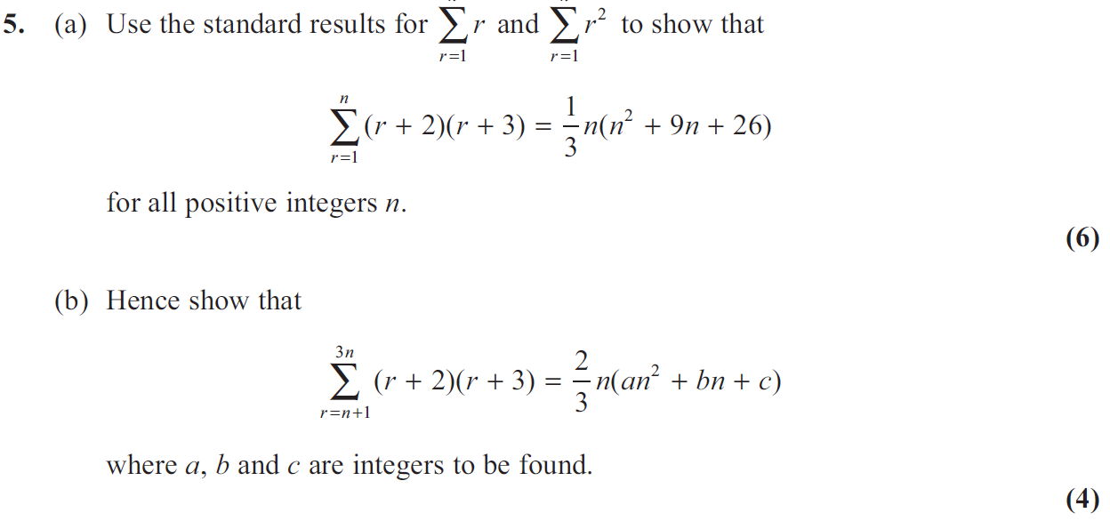

2. 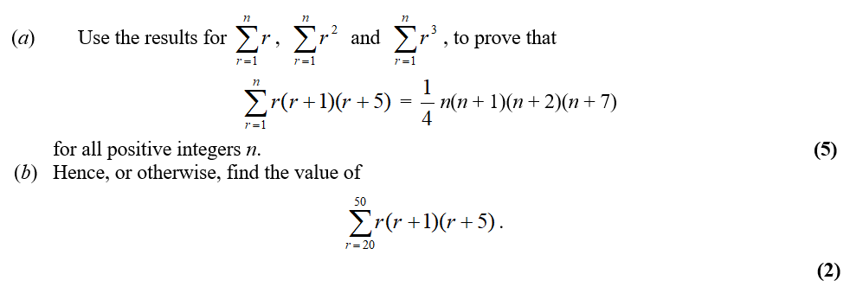

Extension: Given that $n$ is even, determine $1^{2}-2^{2}+3^{2}-4^{2}+5^{2}-…-n^{2}$

Exercise 3B Page 46-47

