3B Mean Value of a Function
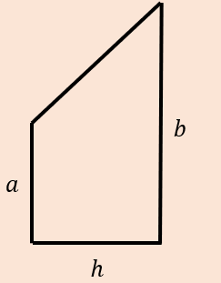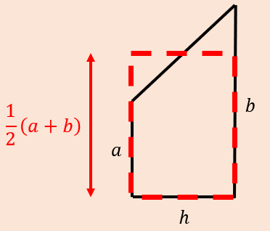

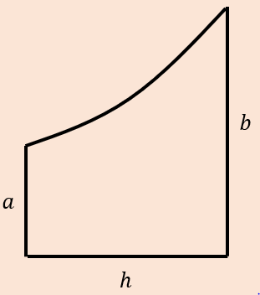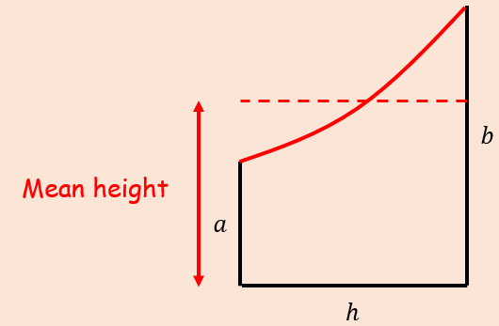

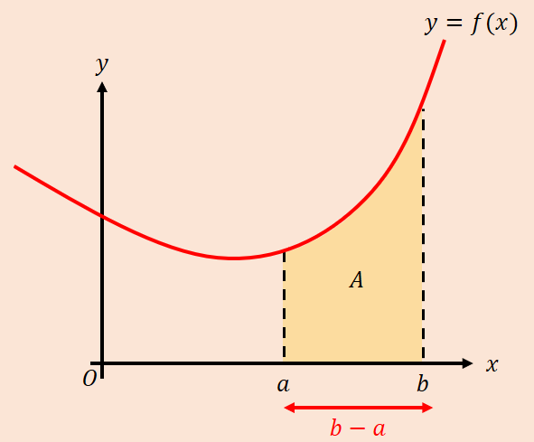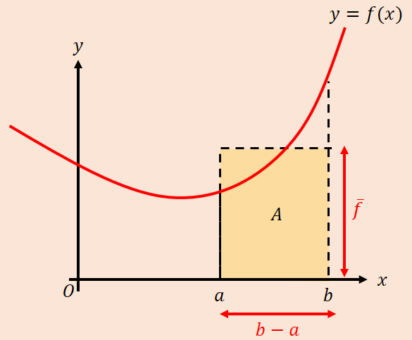

- Find the mean value of $f\left(x\right)=\frac{4}{\sqrt{2+3x}}$ in the interval $\left[2,6\right]$.

- Given that $f\left(x\right)=\frac{4}{1+e^{x}}$
- Show that the mean value of $f(x)$ on the interval $\left[ln2, ln6\right]$ is
$$\frac{4ln\frac{9}{7}}{ln3}$$

- Use your answer to part a) to find the mean value of $f\left(x\right)+4$ over the interval $\left[ln2,ln6\right]$

- Use geometric considerations to write down the mean value of $y=-f(x)$ over the interval $\left[ln2,ln6\right]$

In General:
Vertical Transformations:

Horizontal Transformations:

