The Mean Value of a Function

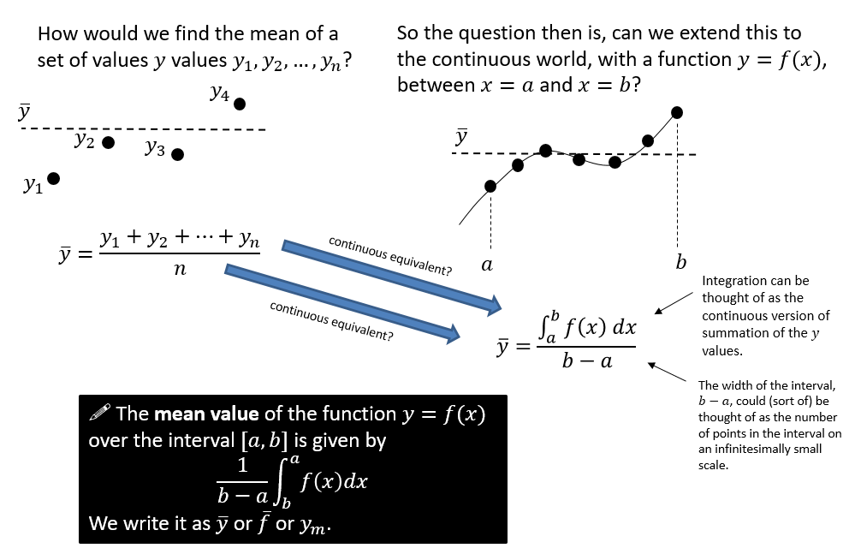

Textbook Example
- Find the mean value of $f\left(x\right)=\frac{4}{\sqrt{2+3x}}$ over the interval $\left[2,6\right]$.

- $f\left(x\right)=\frac{4}{1+e^{x}}$
- Show that the mean value of $f(x)$ over the interval $\left[\ln{2},\ln{6}\right]$ is $\frac{4\ln{\frac{9}{7}}}{\ln{3}}$
- Use your answer to part a to find the mean value over the interval $[\ln{2},\ln{6}]$ of $f\left(x\right)+4$.
Use geometric considerations to write down the mean value of $-f(x)$ over the interval $\left[\ln{2},\ln{6}\right]$

Ex 3B Page 61

