Core Pure 1

Chapter 3: Series

Chapter Overview

1. Sum of 1’s and Integers

2. Breaking down summations

3. Sum of Square and Cubes

4. Dealing with bounds



Starter

Write out the following series:

$\sum_{r=1}^{n}{ r}$

$\sum_{r=1}^{∞}{ r}$

$\sum_{r=1}^{n}{ (2r}-1)$

$\sum_{r=0}^{n-1}{ (2r+1)}$

$\sum_{r=1}^{n}{ (k^{2}+2)}$

Calculate:

$\sum_{p=3}^{8}{ }p^{2}$

$\sum_{r=0}^{5}{{(7r+1)}^{2}}$

The Sum of 1, n times

Example: $$\sum_{r=1}^{n}{ 3}$$

Test your Understanding:

$$1.\sum_{r=1}^{6}{1}$$

$$2. \sum_{r=1}^{7}{3}$$

$$3.\sum_{r=4}^{n}{1}$$

The sum of the first n natural numbers

Examples:

Evaluate

$$1a.\sum_{r=1}^{100}{r}$$

$$1b.\sum_{r=50}^{100}{ r}$$

Test Your Understanding:

Evaluate:

$$1a.\sum_{r=1}^{50}{r}$$

$$1b.\sum_{r=21}^{50}{ r}$$

Further Examples:

2. Show that $$\sum_{r=5}^{2N-1}{r}=2N^{2}-N-10$$ 
(for $N≥3$)

1. Show that $\sum_{r=k-1}^{2k}{r}=\frac{(k-2)(3k-1)}{2} , k≥1$

Test Your Understanding:

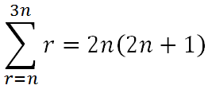

Show that

Breaking up Summations

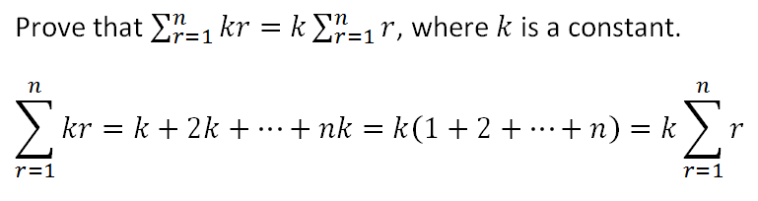

Examples:

$$1. \sum_{r=1}^{n}{3r}$$

$$2.\sum_{r=1}^{n}{4}$$

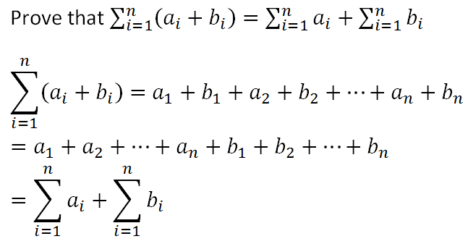

Combining the previous 2 statements leads to the following result:

$$\sum_{r=1}^{n}{(ar+b)}=a\sum_{r=1}^{n}{r}+b\sum_{r=1}^{n}{1}$$

Examples

$$1.\sum_{r=1}^{25}{(3r+1)}$$

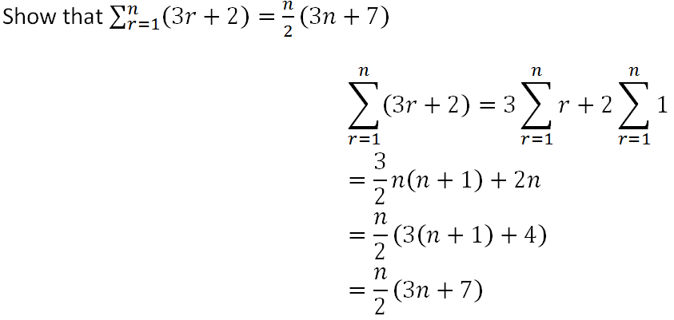2.

Hence evaluate $\sum_{r=20}^{50}{(3r+2)}$

Test Your Understanding

1. Show that $\sum_{r=1}^{n}{\left(7r-4\right)=\left(\frac{n}{2}\right)\left(7n-1\right) }$ and hence evaluate $\sum_{r=20}^{50}{(7r-4)}$

Exercise 3A Page 46-47