3A Improper Integrals

- Calculate the area indicated in the diagram
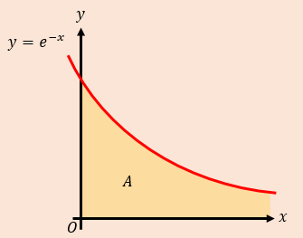

- Evaluate the integral below, or show that it is not convergent.

$$\int_{1}^{∞}{\frac{1}{x^{2}} dx}$$

$$\int_{1}^{∞}{\frac{1}{x} dx}$$

$$\int_{0}^{1}{\frac{1}{x^{2}} dx}$$

$$\int_{0}^{2}{\frac{x}{\sqrt{4-x^{2}}} dx}$$

$$\int_{-∞}^{∞}{f\left(x\right) dx}=\int_{-∞}^{c}{f\left(x\right) dx}+\int_{c}^{∞}{f\left(x\right) dx}$$

- Find $\int{xe^{-x^{2}}} dx$

- Hence, show that $\int_{-∞}^{∞}{xe^{-x^{2}}} dx$ converges, and find its value

A final thought on positive and negative areas and the difference between ‘find the integral’, and ‘find the area’

