CP2, Chapter 3
Methods in Calculus

Course Structure
- Improper Integrals
- Mean Value of a Function
- Differentiating and Integrating Inverse Trig Functions
- Integrating using Partial Fractions

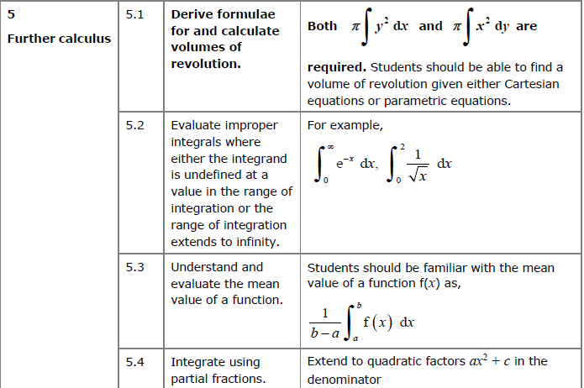
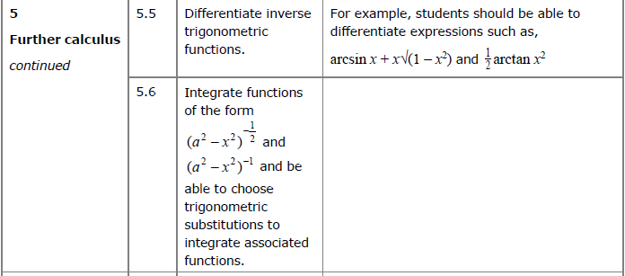

Improper Integrals

STARTER 1: Determine $\int_{-1}^{1}{\frac{1}{x^{2}} dx}$. Is there an issue?

STARTER 2: Determine $\int_{-1}^{1}{\frac{1}{x^{2}} dx}$. Is there an issue?

STARTER 3: Determine $\int_{0}^{1}{\frac{1}{\sqrt{x}} dx}$. Is there an issue?

If a function $f\left(x\right)$ exists and is continuous for all values of x in the interval $\left[a,b\right]$ then the definite integral $\int_{a}^{b}{f\left(x\right) dx}$ represents the area enclosed by the curve $y=f\left(x\right),$ the x axis and the lines $x=a$ and $x=b.$
Here, we consider integrals where one or both of the limits are infinite, or where the function is not defined at some point within in the given interval. These are called improper integrals. In these cases, it is still possible for the function to enclose a finite area.
The integral $\int_{a}^{b}{f\left(x\right) dx}$ is improper if either:
- One or both of the limits is infinite
- $f(x)$ is undefined at $x=a, x=b$ are another point in the interval $[a,b]$.

If an improper integral exists it is said to be convergent. If it does not exist it is said to be divergent.

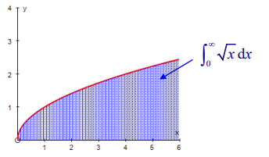
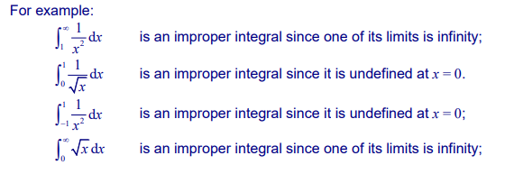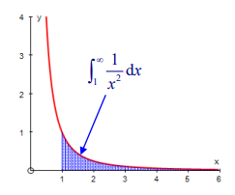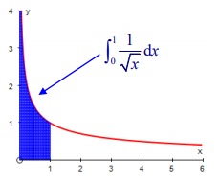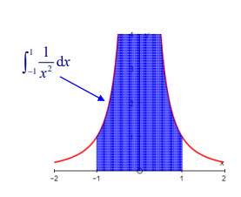

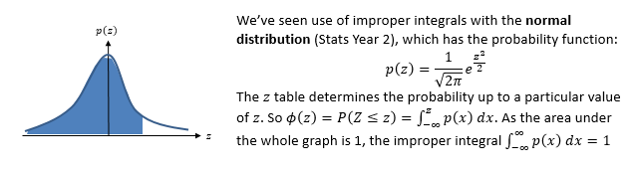

We can’t use $∞$ in calculations directly. We can make use of the $lim$ function we saw in differentiation by first principles.
To find $\int_{a}^{∞}{f\left(x\right) dx}$, determine $\lim_{t→∞}\int_{a}^{t}{f\left(x\right) dx}$

Examples

1.Evaluate $\int_{1}^{∞}{\frac{1}{x^{2}} dx}$ or show that it is not convergent.

2. Evaluate $\int_{1}^{∞}{\frac{1}{x} dx}$ or show that it is not convergent.

Undefined Values of $f\left(x\right)$
We need to avoid values with the range $[a,b]$ for which the expression is not defined. But just as we avoided $∞$ by considering the limit as $t→∞$, we can similarly find what the area converges to as $x$ tends towards the undefined value.

Examples
- Evaluate $\int_{0}^{1}{\frac{1}{x^{2}} dx}$ or show that it is not convergent.

- Evaluate $\int_{0}^{2}{\frac{x}{\sqrt{4-x^{2}}} dx}$ or show that it is not convergent.

Further Examples
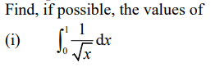

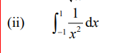

Integrating between $-∞$ and $∞$

If both limits in the integral are infinite, then you need to split the integral into the sum of 2 improper integrals.

If both these integrals converge, then the original integral converges, but if either diverges, then the original integral is also divergent.

Example

(a) Find $\int{xe^{-x^{2}}dx}$

(b) Hence show that $\int_{-∞}^{∞}{xe^{-x^{2}}}dx$ converges and find its value.

Ex 3a, pages 56-58

