3A Improper Integrals

- Calculate the area indicated in the diagram
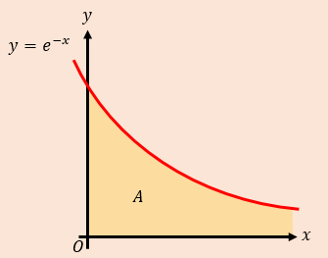

- Evaluate the integral below, or show that it is not convergent.

$$\int_{1}^{∞}{\frac{1}{x^{2}} dx}$$

$$\int_{1}^{∞}{\frac{1}{x} dx}$$

$$\int_{0}^{1}{\frac{1}{x^{2}} dx}$$

$$\int_{0}^{2}{\frac{x}{\sqrt{4-x^{2}}} dx}$$

$$\int_{-∞}^{∞}{f\left(x\right) dx}=\int_{-∞}^{c}{f\left(x\right) dx}+\int_{c}^{∞}{f\left(x\right) dx}$$

- Find $\int{xe^{-x^{2}}} dx$

- Hence, show that $\int_{-∞}^{∞}{xe^{-x^{2}}} dx$ converges, and find its value

A final thought on positive and negative areas and the difference between ‘find the integral’, and ‘find the area’

3B Mean Value of a Function
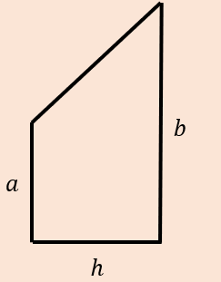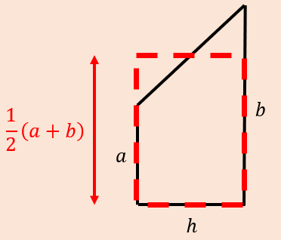

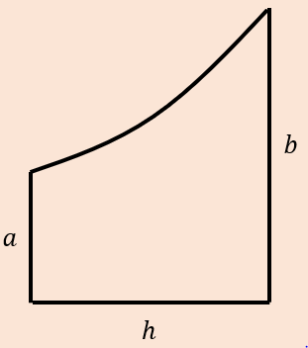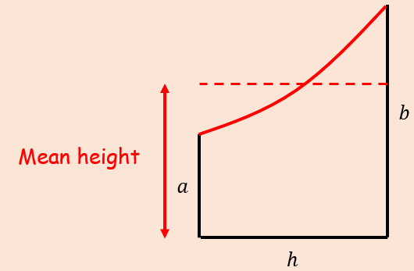

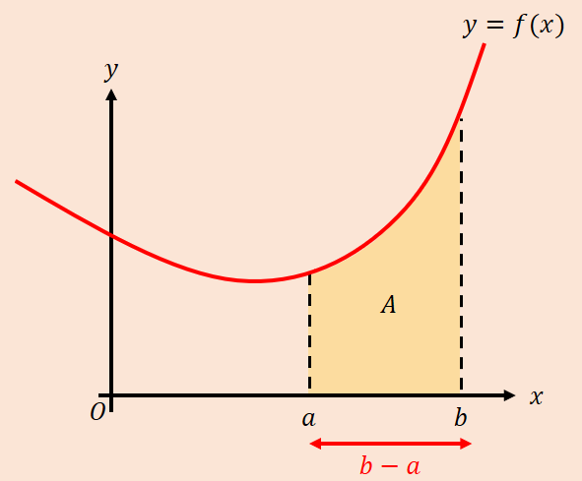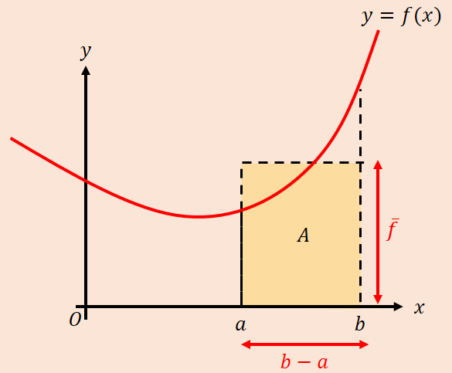

- Find the mean value of $f\left(x\right)=\frac{4}{\sqrt{2+3x}}$ in the interval $\left[2,6\right]$.

- Given that $f\left(x\right)=\frac{4}{1+e^{x}}$
- Show that the mean value of $f(x)$ on the interval $\left[ln2, ln6\right]$ is
$$\frac{4ln\frac{9}{7}}{ln3}$$

- Use your answer to part a) to find the mean value of $f\left(x\right)+4$ over the interval $\left[ln2,ln6\right]$

- Use geometric considerations to write down the mean value of $y=-f(x)$ over the interval $\left[ln2,ln6\right]$

In General:
Vertical Transformations:

Horizontal Transformations:
3C Differentiating Inverse Trig Functions

- Show that $\frac{d}{dx}\left(arcsinx\right)=\frac{1}{\sqrt{1-x^{2}}}$

- $\frac{d}{dx}\left(arccosx\right)=-\frac{1}{\sqrt{1-x^{2}}}$

- Find $\frac{d}{dx}\left(arctanx\right)$

- Given $y=arcsinx^{2}$, find $\frac{dy}{dx}$
- Using implicit differentiation

- Using the chain rule and the formula for $\frac{d}{dx}(arcsinx)$

A Key point on the chain rule above: don’t just multiply by the derivative! (as x does not remain x in the derivative)

- Given $y=arctan\left(\frac{1-x}{1+x}\right)$, find $\frac{dy}{dx}$

- Show that
$$sin\left(arccosx\right)=\sqrt{1-x^{2}}$$

3D Integrating with Trig Substitutions

$$\int{\frac{1}{\sqrt{a^{2}-x^{2}}} dx}$$

- Find the integral:
$$\int{\frac{1}{a^{2}+x^{2}} dx}$$

A reminder of the formula book
- Find
$$\int{\frac{4}{5+x^{2}} dx}$$

- Find
$$\int{\frac{1}{25+{9x}^{2}} dx}$$

- Evaluate the following, leaving your answer in terms of $π$.
$$\int_{-\frac{\sqrt{3}}{4}}^{\frac{\sqrt{3}}{4}}{\frac{1}{\sqrt{3-{4x}^{2}}} dx}$$

- Find
$$\int{\frac{x+4}{\sqrt{1-{4x}^{2}}} dx}$$

3E Integrating with Partial Fractions
- Prove that:
$$\int{\frac{1}{a^{2}-x^{2}} dx=\frac{1}{2a}ln\left|\frac{a+x}{a-x}\right|+c}$$

- Show that:
$$\int{\frac{1+x}{x^{3}+9x} dx=Aln\left(\frac{x^{2}}{x^{2}+9}\right)+Barctan\left(\frac{x}{3}\right)+c}$$
where $A$ and $B$ are constants to be found.

- Express the following as partial fractions
$$\frac{x^{4}+x}{x^{4}+{5x}^{2}+6}$$

- Hence, find:
$$\int{\frac{x^{4}+x}{x^{4}+{5x}^{2}+6} dx}$$

