2F Shading Regions on Argand Diagrams

- Shade on an Argand diagram the region indicated by:

$$\left|z-4-2i\right|≤2$$
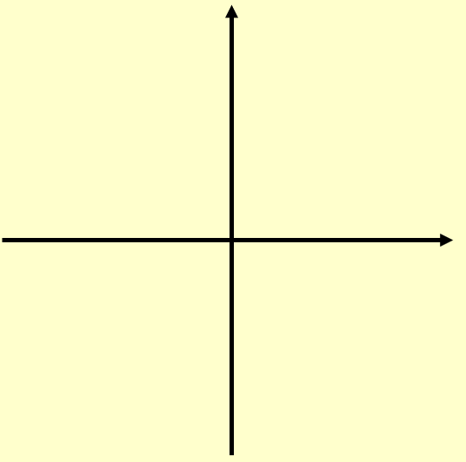

$$\left|z-4\right|<\left|z-6\right|$$

$$0≤arg\left(z-2-2i\right)≤\frac{π}{4}$$

