2E Loci on Argand Diagrams

$$\left|z-z_{1}\right|=r$$
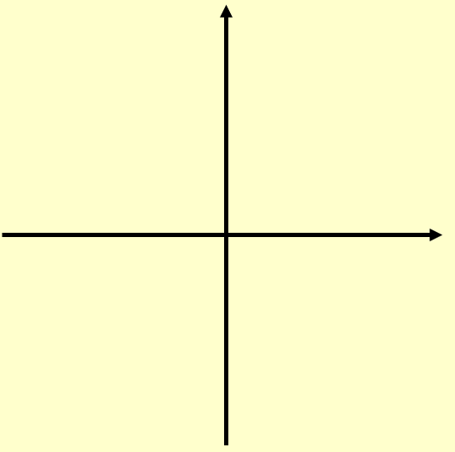

- Given that $\left|z-4\right|=5$

- Sketch the locus of z on an Argand diagram

- Find the values of z that satisfy:
- $\left|z-4\right|=5$ and $Im\left(z\right)=0$

- $\left|z-4\right|=5$ and $Re\left(z\right)=0$

- If $\left|z-5-3i\right|=3$
- Sketch the locus of P(x,y) which is represented by z on an Argand diagram
- Find the maximum value of argz in the interval (-π,π)
- Use an algebraic method to find a Cartesian equation of the locus of z

- Given that the complex number z = x + iy satisfies the equation:
$$\left|z-12-5i\right|=3$$
Find the minimum and maximum values of |z|

Notes on Loci for |z-z₁|=|z-z₂|
- Sketch the locus of P(x,y) which is represented by z on an Argand diagram, if:

$$\left|z\right|=\left|z-6i\right|$$

- Show that the locus is y = 3 using an algebraic method

- Use an algebraic method to find the Cartesian equation of the locus of z if:
$$\left|z-3\right|=\left|z+i\right|$$

- Represent the locus of z on a cartesian set of axes

Notes on Loci for argz = ɵ
- If
$$argz=\frac{π}{4}$$
Sketch the locus of P(x,y) which is represented by z on an Argand diagram. Then find the Cartesian equation of this locus algebraically.

- If
$$arg⁡(z-2)=\frac{π}{3}$$
Sketch the locus of P(x,y) which is represented by z on an Argand diagram. Then find the Cartesian equation of this locus algebraically.

- If
$$arg⁡(z+3+2i)=\frac{3π}{4}$$
Sketch the locus of z on an Argand diagram and use an algebraic method to find the equation of the line.

