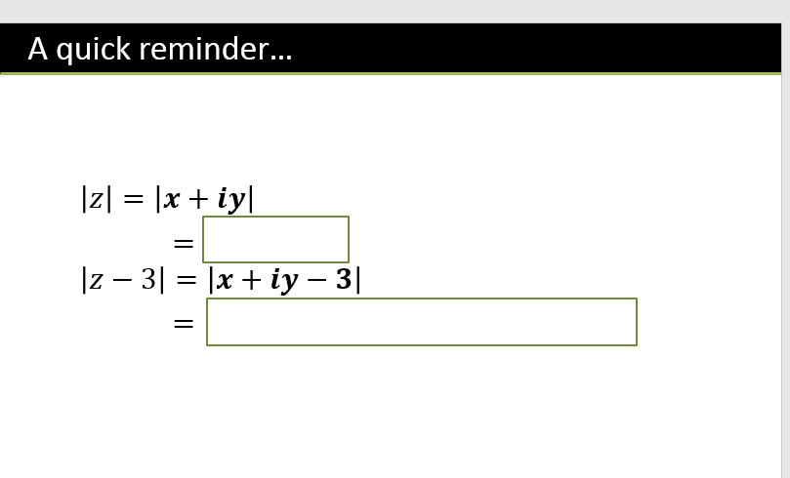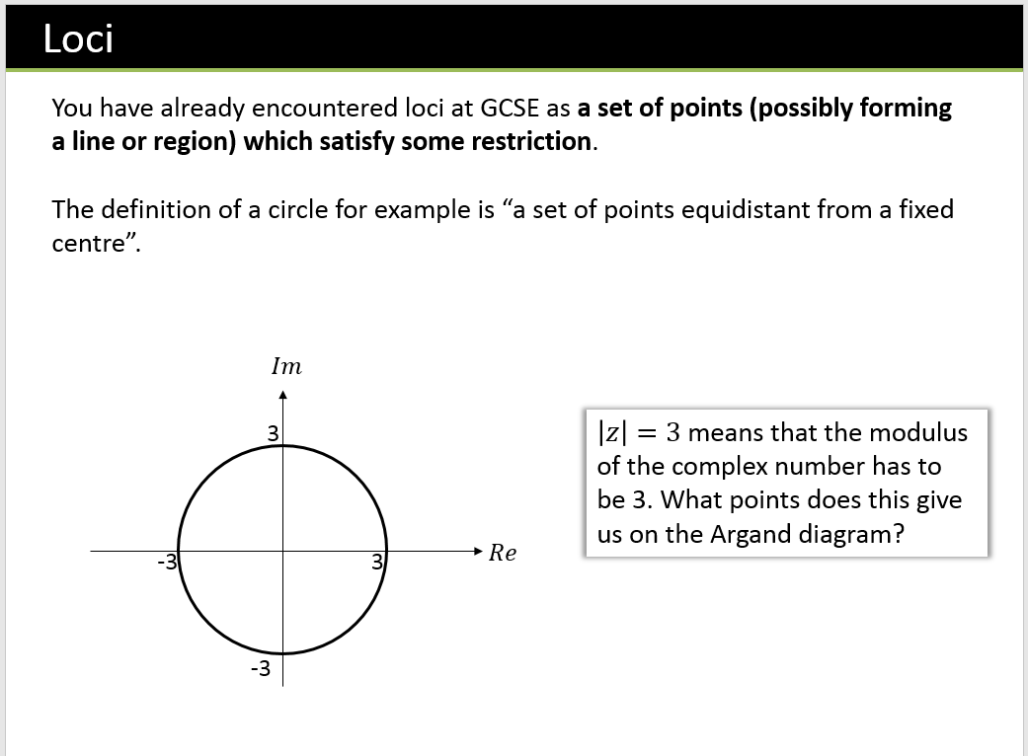

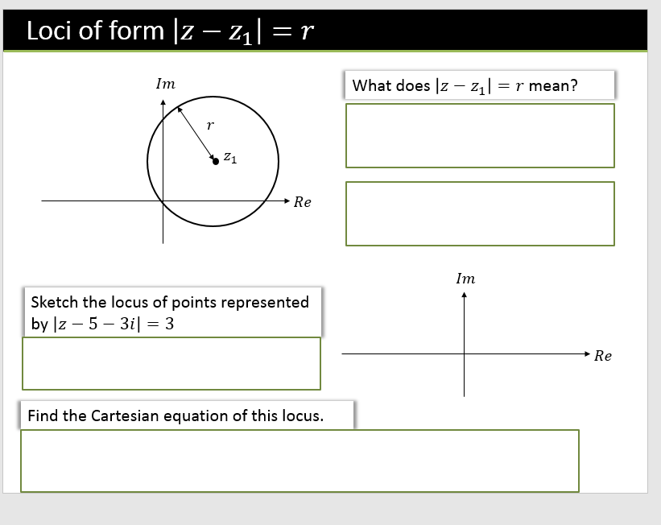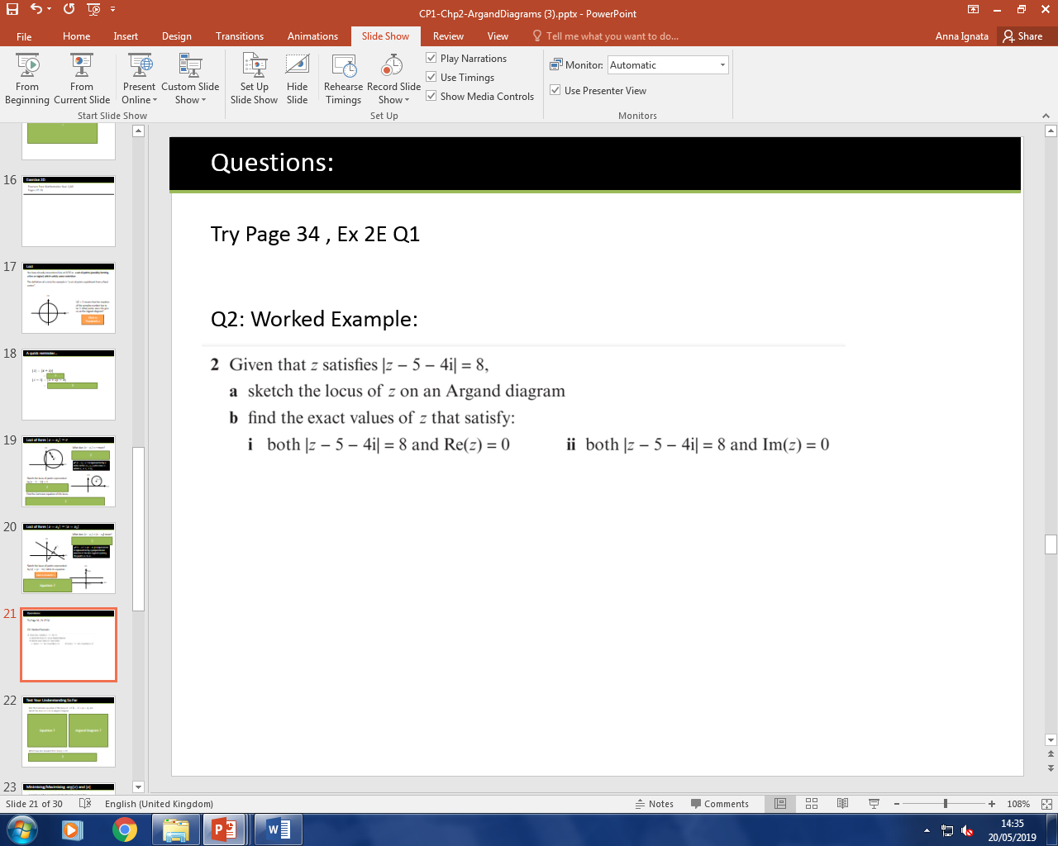

What does $\left|z-z_{1}\right|=\left|z-z_{2}\right|$ mean?

Loci of form $\left|z-z_{1}\right|=\left|z-z_{2}\right|$



Example,

Sketch the locus of points represented by $\left|z\right|=|z-6i|$. Write its equation.

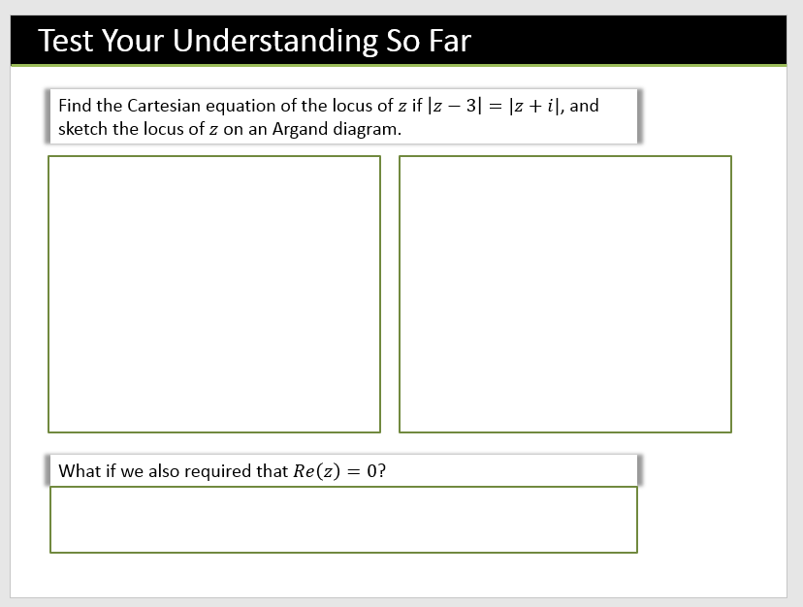

Minimising/Maximising $arg⁡(z)$ and $|z|$

A complex number $z$ is represented by the point $P$. Given that $\left|z-5-3i\right|=3$

1. Sketch the locus of $P$
2. Find the Cartesian equation of the locus.
3. Find the maximum value of $\arg{z}$ in the interval $\left(-π,π\right)$
4. Find the minimum and maximum values of $|z|$

We did this earlier…

1. b)

c)

d)

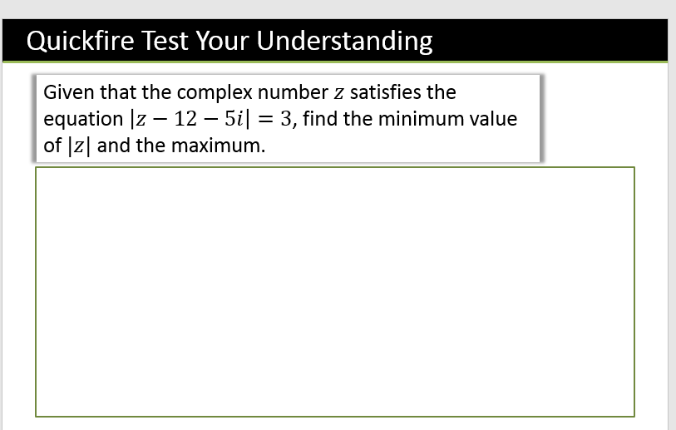

(From earlier) Find the Cartesian equation of the locus of $z$ if $\left|z-3\right|=|z+i|$, and sketch the locus of $z$ on an Argand diagram.

Minimising $|z|$ with perpendicular bisectors

**Hence, find the least possible value of $|z|$.**

$\arg\left(z\right)=\frac{π}{6}$?

$\arg\left(z-z_{1}\right)=θ$

$\arg\left(z+3+2i\right)=\frac{3π}{4}$?