2D Composite Maclaurin Series
Formula Book Formulae:
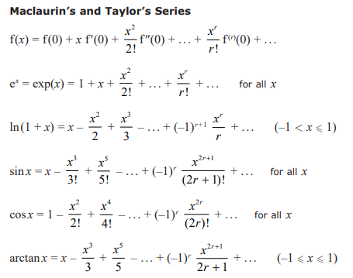

- Write down the first 4 non-zero terms in the series expansion of cos(2x²)

- Find the first 4 non-zero terms in the series expansion of:
$$ln\left\{\frac{\sqrt{1+2x}}{1-3x}\right\}$$

- Given that terms in x^{n}, n > 4 can be ignored, show, using the series expansions of e^{x} and sinx, that:
$$e^{sinx}≈1+x+\frac{x^{2}}{2}-\frac{x^{4}}{8}$$

