2C Modulus-Argument Form

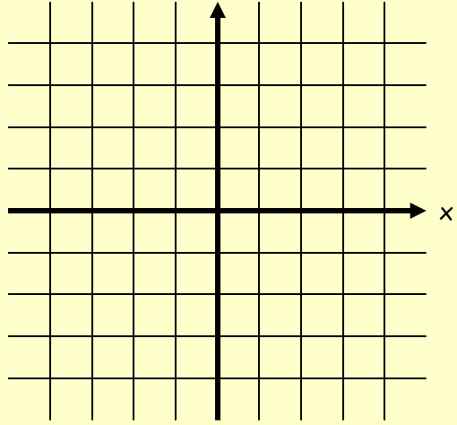

- Express the numbers following numbers in the modulus argument form:
- $z_{1}=1+i\sqrt{3}$

- $z_{2}=-3-3i$

