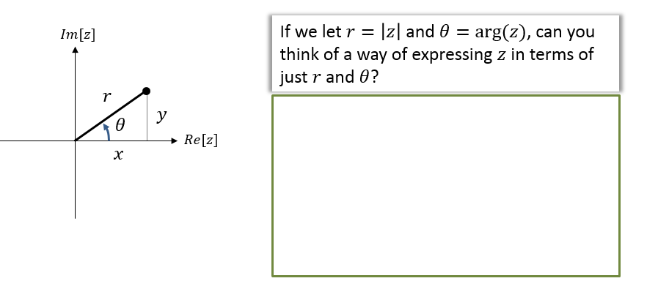

Modulus-Argument Form

**Context: $\left(r,θ\right)$** is known as a polar coordinate and you learn about these in Core Pure Year 2. Instead of coordinates being specified by their $x$ and $y$ position (known as a Cartesian coordinate), they are specified by their distance from the origin (the ‘pole’) and their rotation.

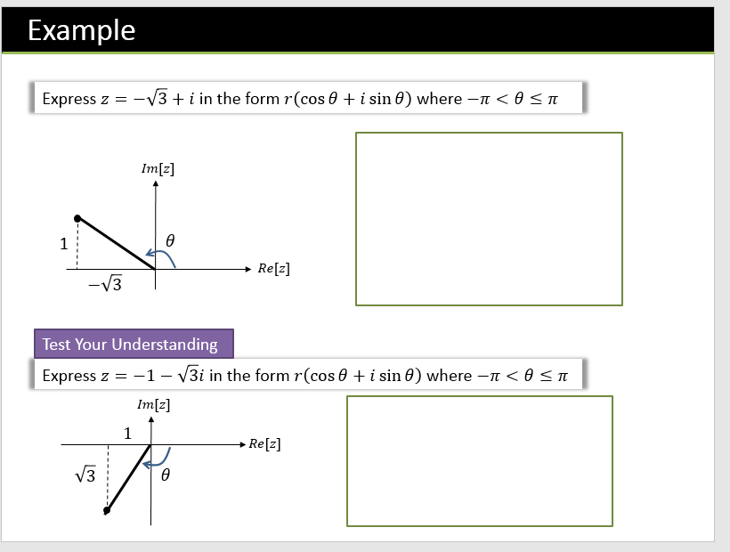

Exercise 2C Page 24