2B Modulus & Argument
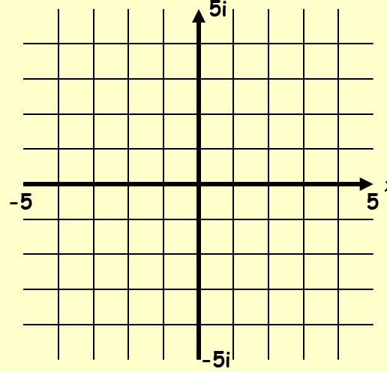

- Find, to two decimal places, the modulus and argument of z = 4 + 5i

- Find, to two decimal places, the modulus and argument of z = -2 + 4i

- Find, to two decimal places, the modulus and argument of z = -3 - 3i

