Modulus and argument
$4+3i$ is plotted on an Argand diagram.
- What is its distance from the origin?
- What is its anti-clockwise angle from the positive real axis? (in radians)
$$Re[z]$$
$$Im[z]$$
4
3
$$θ$$
a)

b)

These are respectively known as the modulus $|z|$ and argument $arg⁡(z)$ of a complex number.

Examples
Determine the modulus and argument of:
- $5+12i$

- $-1+i$

- $-2i$

- $-1-3i$

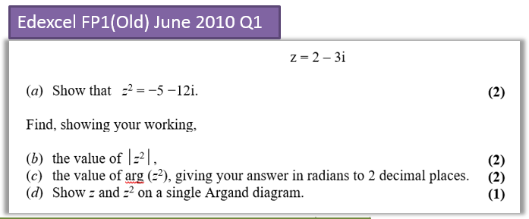

Exercise 2B Page 21

