2A Introduction to Argand Diagrams
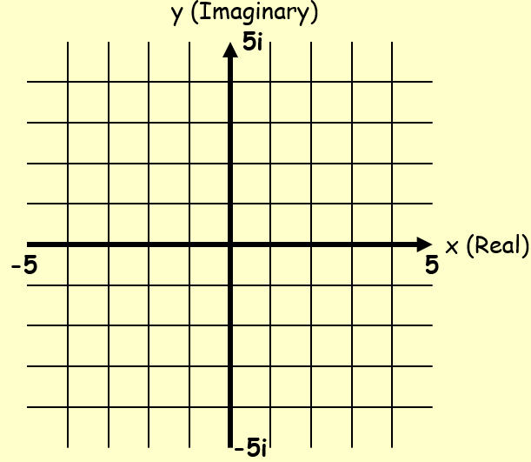

- Represent the following complex numbers on an Argand diagram:
$$z_{1}=2+5i$$
$$z_{2}=3-4i$$
$$z_{3}=-4+i$$
Find the magnitude of |OA|, |OB| and |OC|, where O is the origin of the Argand diagram, and A, B and C are z₁, z₂ and z₃ respectively

- $z_{1}=4+i$ $z_{2}=3+3i$
Show z₁, z₂ and z₁ + z₂ on an Argand diagram
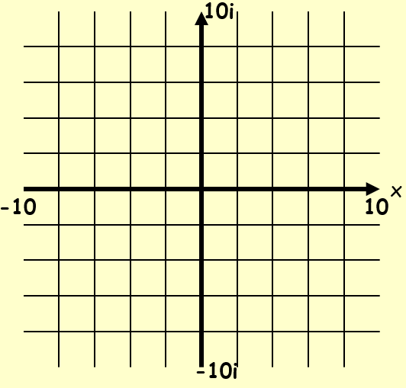

- $z_{1}=2+5i$ $z_{2}=4+2i$
Show z₁, z₂ and z₁ - z₂ on an Argand diagram

