Core Pure 1
Argand diagrams
Chapter Overview
1: Represent complex numbers on an Argand Diagram.
2: Put a complex number in modulus-argument form.
3: Identify loci and regions.

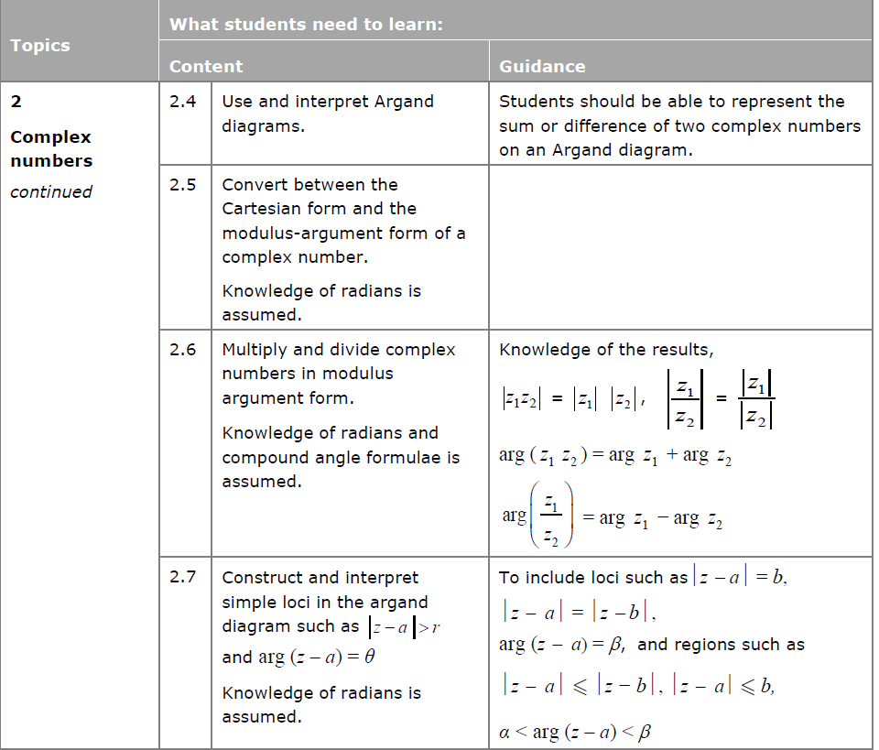
Argand diagrams
Just as $x$-$y$ axes were a useful way to visualise coordinates, an Argand diagram allows us to visualise complex numbers.

$Re$ is a function which gives you the real part of a complex number. e.g. $Re\left(3+2i\right)=3$.
$$Im(z)$$
$$Re(z)$$
-3 -2 -1 1 2 3
3

2

1

-1

-2

-3

Exercise 2A Page 19

