2A Introduction to Argand Diagrams
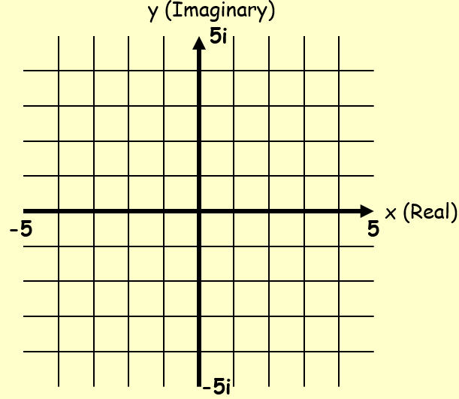

- Represent the following complex numbers on an Argand diagram:
$$z_{1}=2+5i$$
$$z_{2}=3-4i$$
$$z_{3}=-4+i$$
Find the magnitude of |OA|, |OB| and |OC|, where O is the origin of the Argand diagram, and A, B and C are z₁, z₂ and z₃ respectively

- $z_{1}=4+i$ $z_{2}=3+3i$
Show z₁, z₂ and z₁ + z₂ on an Argand diagram
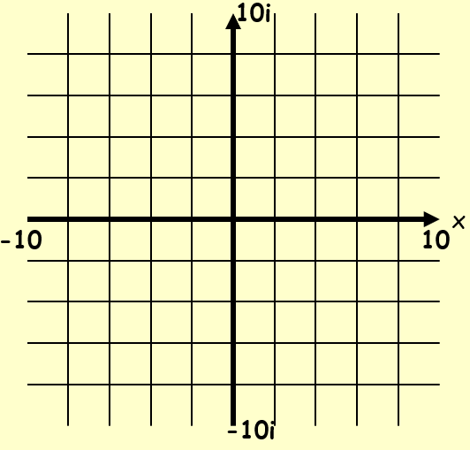

- $z_{1}=2+5i$ $z_{2}=4+2i$
Show z₁, z₂ and z₁ - z₂ on an Argand diagram

2B Modulus & Argument

- Find, to two decimal places, the modulus and argument of z = 4 + 5i

- Find, to two decimal places, the modulus and argument of z = -2 + 4i

- Find, to two decimal places, the modulus and argument of z = -3 - 3i

2C Modulus-Argument Form

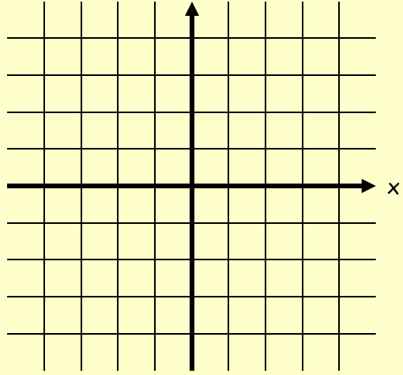

- Express the numbers following numbers in the modulus argument form:
- $z_{1}=1+i\sqrt{3}$

- $z_{2}=-3-3i$

2D Multiplying & Dividing in Modulus-Argument Form

- Express the following calculation in the form x + iy:

$$3\left(cos\frac{5π}{12}+isin\frac{5π}{12}\right)×4\left(cos\frac{π}{12}+isin\frac{π}{12}\right)$$

$$2\left(cos\frac{π}{15}+isin\frac{π}{15}\right)×3\left(cos\frac{2π}{5}-isin\frac{2π}{5}\right)$$

$$\frac{\sqrt{2}\left(cos\frac{π}{12}+isin\frac{π}{12}\right)}{2\left(cos\frac{5π}{6}+isin\frac{5π}{6}\right)}$$

2E Loci on Argand Diagrams

$$\left|z-z_{1}\right|=r$$
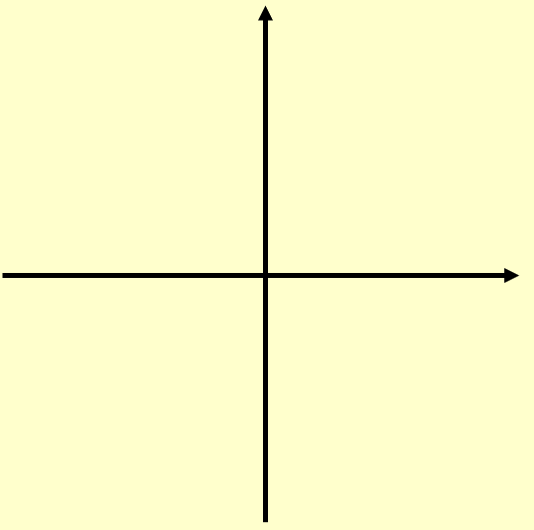

- Given that $\left|z-4\right|=5$

- Sketch the locus of z on an Argand diagram

- Find the values of z that satisfy:
- $\left|z-4\right|=5$ and $Im\left(z\right)=0$

- $\left|z-4\right|=5$ and $Re\left(z\right)=0$

- If $\left|z-5-3i\right|=3$
- Sketch the locus of P(x,y) which is represented by z on an Argand diagram
- Find the maximum value of argz in the interval (-π,π)
- Use an algebraic method to find a Cartesian equation of the locus of z

- Given that the complex number z = x + iy satisfies the equation:
$$\left|z-12-5i\right|=3$$
Find the minimum and maximum values of |z|

Notes on Loci for |z-z₁|=|z-z₂|
- Sketch the locus of P(x,y) which is represented by z on an Argand diagram, if:

$$\left|z\right|=\left|z-6i\right|$$

- Show that the locus is y = 3 using an algebraic method

- Use an algebraic method to find the Cartesian equation of the locus of z if:
$$\left|z-3\right|=\left|z+i\right|$$

- Represent the locus of z on a cartesian set of axes

Notes on Loci for argz = ɵ
- If
$$argz=\frac{π}{4}$$
Sketch the locus of P(x,y) which is represented by z on an Argand diagram. Then find the Cartesian equation of this locus algebraically.

- If
$$arg⁡(z-2)=\frac{π}{3}$$
Sketch the locus of P(x,y) which is represented by z on an Argand diagram. Then find the Cartesian equation of this locus algebraically.

- If
$$arg⁡(z+3+2i)=\frac{3π}{4}$$
Sketch the locus of z on an Argand diagram and use an algebraic method to find the equation of the line.

2F Shading Regions on Argand Diagrams

- Shade on an Argand diagram the region indicated by:

$$\left|z-4-2i\right|≤2$$

$$\left|z-4\right|<\left|z-6\right|$$

$$0≤arg\left(z-2-2i\right)≤\frac{π}{4}$$

