2A Method of Differences

- Show that:
$$4r^{3}=r^{2}{(r+1)}^{2}-{(r-1)}^{2}r^{2}$$

- Hence, prove using the method of differences that:
$$\sum_{r=1}^{n}{r^{3}=\frac{1}{4}n^{2}{(n+1)}^{2}}$$

- Verify that
$$\frac{1}{r(r+1)}=\frac{1}{r}-\frac{1}{r+1}$$
And hence find the following using the method of differences:
$$\sum_{r=1}^{n}{ \frac{1}{r(r+1)}}$$

- Find the following summation using the method of differences:
$$\sum_{r=1}^{n}{ \frac{1}{{4r}^{2}-1}}$$

- Express the following using partial fractions:
$$\frac{2}{(r+1)(r+3)}$$

- Hence prove, by the method of differences, that:
$$\sum_{r=1}^{n}{\frac{2}{(r+1)(r+3)}}= \frac{n(an+b)}{6(n+2)(n+3)}$$
Where a and b are constants to be found.

- Find the value of the following to 5 decimal places:
$$\sum_{r=21}^{30}{\frac{2}{(r+1)(r+3)}}$$

2B Higher Derivatives for Maclaurin Series

- Given that:
$$y=ln\left(1-x\right)$$
Find the value of:
$${\left(\frac{d^{3}y}{{dx}^{3}}\right)}_{\frac{1}{2}}$$

- Given that:
$$f\left(x\right)=e^{x^{2}}$$
- Show that:
$$f'\left(x\right)=2xf(x)$$

- By differentiating the result twice more with respect to x, find f’’(x) and f’’’(x)

- Deduce the values of f(0), f’(0), f’’(0) and f’’’(0)

2C Maclaurin Series

- Given that f(x) = e^{x} can be written in the form:
$$e^{x}=a_{0}+a_{1}x+a_{2}x^{2}+a_{3}x^{3}+ .. . + a_{r}x^{r}$$
And that it is valid to differentiate an infinite series term by term, show that:
$$e^{x}=1+x+\frac{x^{2}}{2!}+\frac{x^{3}}{3!}+ … +\frac{x^{r}}{r!}$$

Generalising:

- Express ln(1 + x) as an infinite series in ascending powers of x, up to and including the term in x³

- Using this series, find approximate values for:
- ln(1.05)

- ln(1.25)

- ln(1.8)

- Find the Maclaurin expansion for sinx, up to the term in x⁵. Then use your expansion to find an approximation for sin10˚.

- Find the Maclaurin expansion for cosx, up to the term in x⁴.

- Proving Euler’s relation:

$$e^{iθ}=cosθ+isinθ$$

2D Composite Maclaurin Series
Formula Book Formulae:
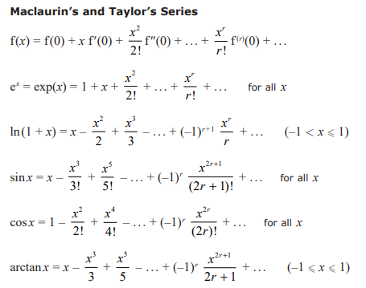

- Write down the first 4 non-zero terms in the series expansion of cos(2x²)

- Find the first 4 non-zero terms in the series expansion of:
$$ln\left\{\frac{\sqrt{1+2x}}{1-3x}\right\}$$

- Given that terms in x^{n}, n > 4 can be ignored, show, using the series expansions of e^{x} and sinx, that:
$$e^{sinx}≈1+x+\frac{x^{2}}{2}-\frac{x^{4}}{8}$$

