1G Geometric Problems with Complex Numbers
- Find the 6th roots of the complex number $7+24i$

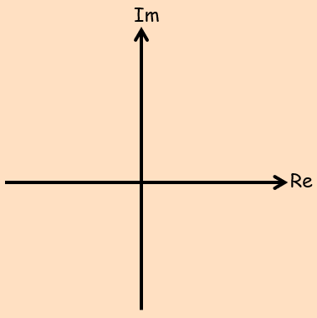

- Find the 6th roots of unity

Summary notes:

- The coordinate $\left(\sqrt{3},1\right)$ lies at one vertex of an equilateral triangle. The centre of the triangle is at the origin.
Find the coordinates of the other vertices of the triangle
