Solving Geometric Problems

We have already seen in the previous exercise that the roots of an equation such as that below give evenly spaced points in the Argand diagram, because the modulus remained the same but we kept adding $\frac{2π}{n}$ to the argument.

These points formed a regular hexagon, and in general for $z^{n}=s$, form a regular $n$-agon.

Recall that $ω$ is the first root of unity of $z^{n}=1$:
$ω=\cos\left(\frac{2π}{n}\right)+i\sin\left(\frac{2π}{n}\right)$.
This has modulus 1 and argument $\frac{2π}{n}$.

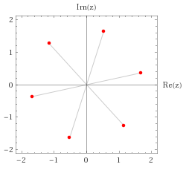

$$z^{6}=7+24i$$

Suppose $z_{1}$ was the first root of $z^{6}=7+24i$. Then consider the product $z_{1}ω$. What happens? Why does this work?

If $z_{1}$ is one root of the equation $z^{6}=s$,
and $1,ω,ω^{2},…,ω^{n-1}$ are the $n$th roots of unity,
then the roots of $z^{n}=s$ are given by
$z_{1},z_{1}ω,z_{1}ω^{2},…,z_{1}ω^{n-1}$.

Example
The point $P\left(\sqrt{3},1\right)$ lies at one vertex of an equilateral triangle. The centre of the triangle is at the origin.
- Find the coordinates of the other vertices of the triangle.
- Find the area of the triangle.

Test your understanding

An equilateral triangle has its centroid located at the origin and a vertex at (1,0). What are the coordinates of the other two vertices?

Ex 1G pg 26

