1F nth Roots of Complex Numbers

- Solve the equation z³ = 1 and represent your solutions on an Argand diagram.

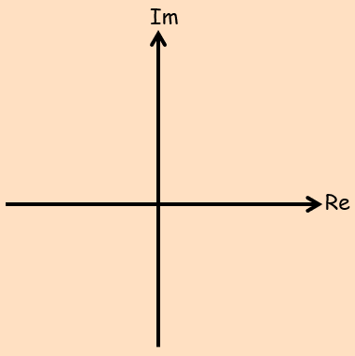
- Show that the three cube roots of 1 can be written as $1+ω+ω^{2}$ where $1+ω+ω^{2}=0$

Summary notes:

- Solve the equation $z^{4}-2\sqrt{3}i=2$
Give your answers in both the modulus-argument and exponential forms.

- Solve the equation:
$$z^{3}+4\sqrt{2}+4i\sqrt{2}=0$$

