Applications of De’Moivre’s Theorem 2: Roots
De Moivre’s theorem also holds true for rational powers. We can use De Moivre’s to solve equations of the form $z^{n}=w$, where $z,w∈∁$. This is equivalent to finding the nth roots of $w$

The fundamental theorem of algebra holds true for complex numbers:
Hence $z^{n}=w$, where $z,w∈∁$ has n distinct roots.
If w = 1 we call these roots of unity.
To find the roots of a complex equation we use the fact that the argument of a complex number is not unique:
If $z^{n}=r^{n}\left(cosnθ+isinnθ\right)$then $z=r(\cos\left(θ+2Kπ\right)+isin(θ+2kπ)$)

Roots of Unity Example
Solve $z^{3}=1$
Method 1: By factorising Method 2: De Moivre’s

Notice:
- The first root will always be 1 since $1^{n}=1$

- We add $\frac{2kπ}{n}$ to the argument but leave the modulus unchanged e.g. when $n=3$ we rotate the line $\frac{2π}{3}$ each time. When $k=n$ we have rotated $\frac{2πn}{n}=2π$ so we get back to where we started.

- The first root is z₁ = 1, call the second root z₂ = $ω$. Then…

$ω=r\left(\cos\left(\frac{2π}{n}\right)+isin\left(\frac{2π}{n}\right)\right)$ $r=1$

Consider $ω^{2}=$

$=$

$=$

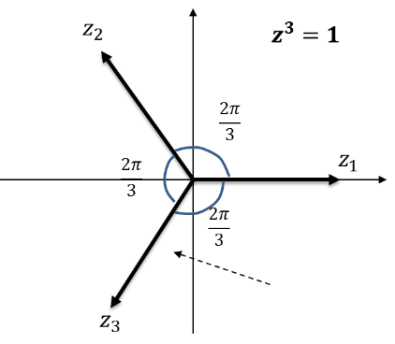
What do you notice?

What would z₃ be?

The roots of $z^{n}=1$can be represented as $1, ω, ω^{2}, where ω=e^{\frac{2πi}{n}}.$
Since the resultant ‘vector’ is 0, then $1+ω+ω^{2}=0$

These roots form the vertices of a regular n-gon and all lie on a circle, radius r.

General nth Roots: $z^{n}=w, w≠1$

We can use a similar method when w is not equal to 1. Again, our first step is to write w in mod-arg form and consider multiples of the argument.

Example
Solve $z^{4}=2+2\sqrt{3} i$

Test your understanding

- Express the complex number $-2+\left(2\sqrt{3}\right)i$ in the form $r\left(\cos{θ+i\sin{θ}}\right)$, $-π<θ≤π$. (3)
- Solve the equation
$$z^{4}=-2+\left(2\sqrt{3}\right)i$$giving the roots in the form $r\left(\cos{θ}+i\sin{θ}\right)$, $-π<θ≤π$. (5)

Ex 1F pg 24

