Roots of Cubic and Quartic Equations

Cubics

Quartics

Example 1: Find the quadratic equation with roots α = 2+ 4i and β = 2 – 4i in the form $x^{2}+ax+b=0$
(2 Methods)

Quartics

Example 1: Find the quadratic equation with roots α = 2+ 4i and β = 2 – 4i in the form $x^{2}+ax+b=0$
(2 Methods)

Examples
1. [Textbook] Given that $3+i$ is a root of the quartic equation
$2z^{4}-3z^{3}-39z^{2}+120z-50=0$, solve the equation completely.

2. [Textbook] Show that $z^{2}+4$ is a factor of $z^{4}-2z^{3}+21z^{2}-8z+68$. Hence solve the equation $z^{4}-2z^{3}+21z^{2}-8z+68=0$

Test Your Understanding:
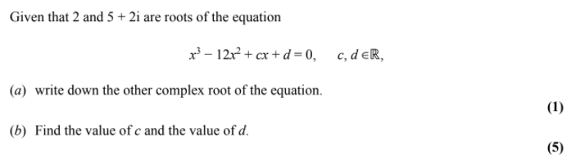
Exercise 1F Page 13 - 14

