Applications of de Moivre’s

Trig identities
De Moivre’s theorem can be used to give multiple angle expressions ($\cos{nθ }$/ $\sin{nθ}$) in terms of powers, and to express powers of sin and cos in terms of multiple angles. This is useful in integration.
We derive these identities by applying the binomial expansion to$(cosθ+{isinθ)}^{n}$
Recap
${\left(a+b\right)}^{n}=a^{n}+\left({n \atop 1}\right)a^{n-1}b+\left({n \atop 2}\right)a^{\left(n-2\right)}b^{2}$+….

- Expressing $\cos{nθ }$and $\sin{nθ}$ in terms of powers of $\cos{θ}$

Example
Express $\cos{3θ}$ in terms of powers of $\cos{θ}$

Test Your understanding

- Express $\cos{6θ}$ in terms of $\cos{θ}$

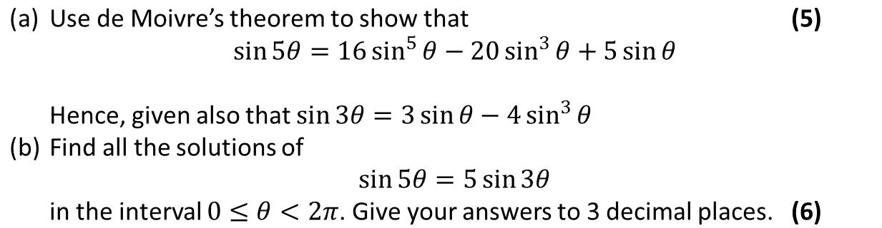
2.

b. Finding expressions for $\sin^{n}{ θ}$ and $\cos^{n}{θ}$

Exponential Form

Examples
1. Express $\cos^{5}{θ}$ in the form $a\cos{5θ}+b\cos{3θ}+c\cos{θ}$

2. Prove that $\sin^{3}{θ}=-\frac{1}{4}\sin{3θ}+\frac{3}{4}\sin{θ}$

Test Your Understanding
a) Express $\sin^{4}{θ}$ in the form $a\cos{4θ}+b\cos{2θ}+c$
(b) Hence find the exact value of $\int_{0}^{\frac{π}{2}}{\sin^{4}{θ} dθ}$

Ex 1D pg 14

