Complex conjugates

Example:
Write $\frac{5+4i}{2-3i}$ in the form $a+bi$

Test Your Understanding
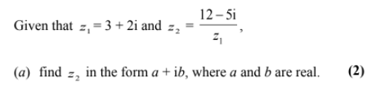
Exercise 1D Page 7-8

