Multiplying Complex Numbers

Examples
- Express each of the following in the form $a+bi$, where $a,b$ are integers.

- $\left(2+3i\right)\left(3-2i\right)$

- ${\left(5-3i\right)}^{2}$

- Determine the value of $i^{3}, i^{4}, i^{101}$ and ${\left(3i\right)}^{5}$

Test Your Understanding:

- Edexcel FP1 June 2010
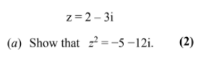

- Expand and simplify ${\left(1+i\right)}^{3}$

Exercise 1C Page 6

