De Moivre’s Theorem

Example
Prove by induction that $z^{n}=r^{n}\left(\cos{nθ}+i\sin{nθ}\right)$

De Moivre’s Theorem: Exponential Form

Examples
- Simplify $\frac{{\left(\cos{\frac{9π}{17}}+i\sin{\frac{9π}{17}}\right)}^{5}}{{\left(\cos{\frac{2π}{17}} - i\sin{\frac{2π}{17}}\right)}^{3}}$

- Express ${\left(1+\sqrt{3} i\right)}^{7}$ in the form $x+iy$ where $x,y∈R$.

Test your understanding

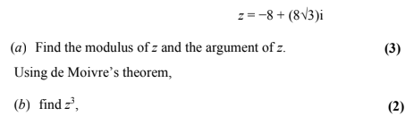

Ex 1C pg 10

