1A Exponential Form
- Express the numbers following numbers in the modulus argument form:
- $z_{1}=1+i\sqrt{3}$
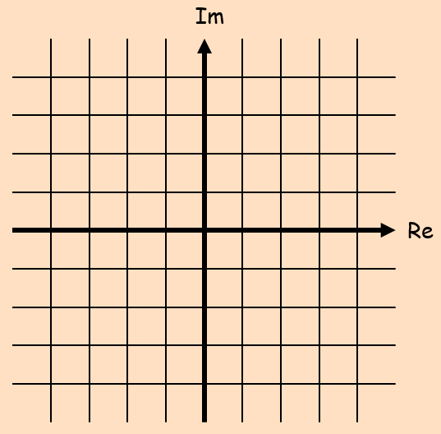

- $z_{2}=-3-3i$

- Express the complex number $z=2 –3i$ in the form ${re}^{iθ}$, where $-π<θ≤ π$

- Express the following in the form $z={re}^{iθ}$ where $–π<θ≤π$
- $z=\sqrt{2}\left(cos\left(\frac{π}{10}\right)+isin\left(\frac{π}{10}\right)\right)$

- $z=5\left(cos\left(\frac{π}{8}\right)-isin\left(\frac{π}{8}\right)\right)$

- Express the following in the form $z=x+iy$ where $x∈R$ and $y∈R$
$$z=\sqrt{2}e^{\frac{3π}{4}i}$$

- Express the following in the form $r(cosθ+isinθ)$, where $–π<θ≤π$
$$z=2e^{\frac{23π}{5}i}$$

- Use: $e^{iθ}=cosθ+isinθ$ To show that: $cosθ=\frac{1}{2}\left(e^{iθ}+e^{-iθ}\right)$

