Chapter 1

Complex Numbers

Chapter Overview

1. Exponential form of a complex number

2. Multiplying and dividing complex numbers

3. De Moivre’s Theorem

4. De Moivre’s for Trigonometric Identities

1. Expressing $\cos{nθ }$/ $\sin{nθ}$ in terms of powers of $\cos{θ}$
2. Finding expressions for and

5. Roots

6. Sums of series



Recap: Mod/ arg form

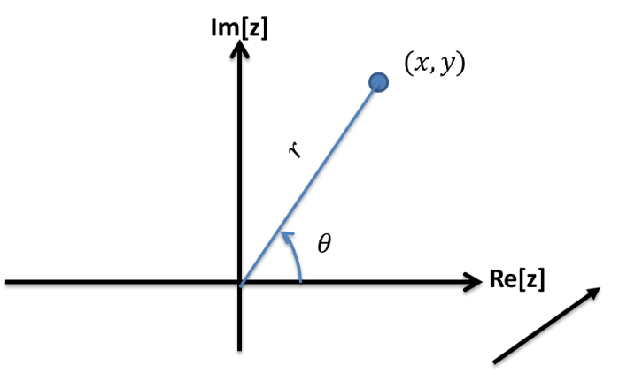

$z=x+iy$

$r=\left|z\right|=$

$θ=arg\left(z\right)=$

$x=$

$y=$

$z=x+iy =$

|  |  |  |  |
| --- | --- | --- | --- |
| $$x+iy$$ | $$r$$ | $$θ$$ | **Mod-arg form** |
| $$-1$$ |  |  |  |
| $$i$$ |  |  |  |
| $$1+i$$ |  |  |  |
| $$-\sqrt{3}+i$$ |  |  |  |

Exponential Form

We’ve seen the Cartesian form a complex number $z=x+yi$ and the modulus-argument form $z=r(\cos{θ+i\sin{θ})}$. But wait, there’s a third form!

In the later chapter on Taylor expansions, you’ll see that you that you can write functions as an infinitely long polynomial:

$$\cos{x}=1 -\frac{x^{2}}{2!} +\frac{x^{4}}{4!} -\frac{x^{6}}{6!} +$$

$$\sin{x} =x -\frac{x^{3}}{3!} +\frac{x^{5}}{5!} -…$$

$$e^{x}= 1+x+\frac{x^{2}}{2!}+\frac{x^{3}}{3!}+\frac{x^{4}}{4!}+\frac{x^{5}}{5!}+\frac{x^{6}}{6!}+$$

It looks like the $\cos{x}$ and $\sin{x}$ somehow add to give $e^{x}$. The one problem is that the signs don’t quite match up.

|  |  |  |
| --- | --- | --- |
| $$x+iy$$ | **Mod-arg form** | **Exp Form** |
| $$-1$$ |  |  |
| $$2-3i$$ |  |  |
|  | $$\sqrt{2}\left(\cos{\frac{π}{10}}+i\sin{\frac{π}{10}}\right)$$ |  |
|  |  | $$z=\sqrt{2}e^{\frac{3πi}{4}}$$ |
|  |  | $$z=2e^{\frac{23πi}{5}}$$ |

**Exponential form $z=re^{iθ}$**

Example

Use $e^{iθ}=\cos{θ}+i\sin{θ}$ to show that $\cos{θ}=\frac{1}{2}(e^{iθ}+e^{-iθ})$

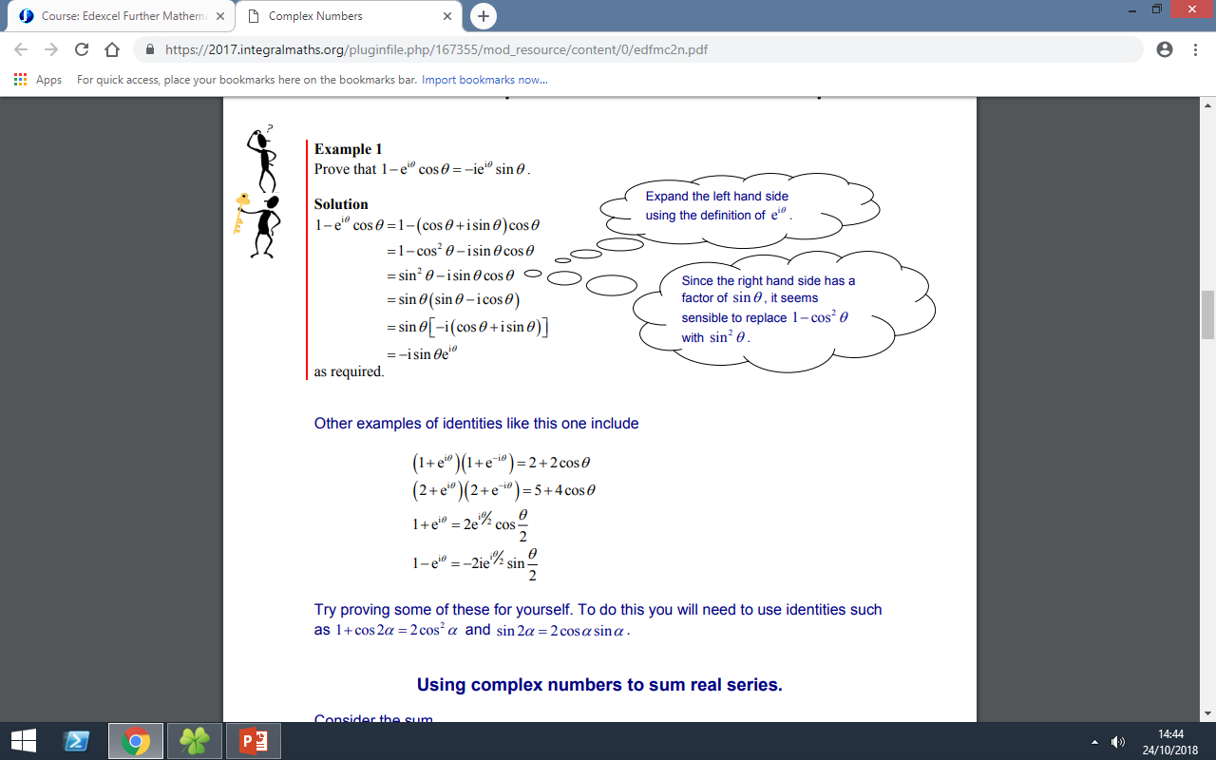

Ex 1a pg 5