1A Exponential Form
- Express the numbers following numbers in the modulus argument form:
- $z_{1}=1+i\sqrt{3}$
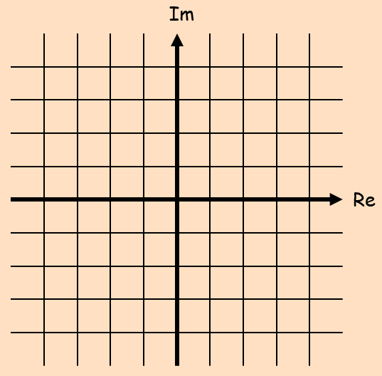

- $z_{2}=-3-3i$

- Express the complex number $z=2 –3i$ in the form ${re}^{iθ}$, where $-π<θ≤ π$

- Express the following in the form $z={re}^{iθ}$ where $–π<θ≤π$
- $z=\sqrt{2}\left(cos\left(\frac{π}{10}\right)+isin\left(\frac{π}{10}\right)\right)$

- $z=5\left(cos\left(\frac{π}{8}\right)-isin\left(\frac{π}{8}\right)\right)$

- Express the following in the form $z=x+iy$ where $x∈R$ and $y∈R$
$$z=\sqrt{2}e^{\frac{3π}{4}i}$$

- Express the following in the form $r(cosθ+isinθ)$, where $–π<θ≤π$
$$z=2e^{\frac{23π}{5}i}$$

- Use: $e^{iθ}=cosθ+isinθ$ To show that: $cosθ=\frac{1}{2}\left(e^{iθ}+e^{-iθ}\right)$

1B Multiplying & Dividing Complex Numbers
- Express the following calculation in the form x + iy:
$$\frac{\sqrt{2}\left(cos\frac{π}{12}+isin\frac{π}{12}\right)}{2\left(cos\frac{5π}{6}+isin\frac{5π}{6}\right)}$$

- Express $2e^{\frac{πi}{6}}×\sqrt{3}e^{\frac{πi}{3}}$ in the form $x+iy$

- $z=2+2i$, $Im\left(zw\right)=0$ and $\left|zw\right|=3\left|z\right|$

1C De Moivre’s Theorem

- Proof by Induction:

Negatives:

0:

- Simplify:
$$\frac{{\left(cos\left(\frac{9π}{17}\right)+isin\left(\frac{9π}{17}\right)\right)}^{5}}{{\left(cos\left(\frac{2π}{17}\right)-isin\left(\frac{2π}{17}\right)\right)}^{3}}$$

- Express ${\left(1+i\sqrt{3}\right)}^{7}$ in the form $x+iy$, where $x,y∈R$

1D Using de Moivre to Prove Trigonometric Identities

- Express cos3θ using powers of cosθ.

- Use De Moivre’s theorem to show that:
$$cos6θ=32\cos^{6}θ-48cos^{4}θ+18\cos^{2}θ-1$$

Further notes:
$$z+\frac{1}{z}$$

$$z-\frac{1}{z}$$

$$z^{n}+\frac{1}{z^{n}}$$

$$z^{n}-\frac{1}{z^{n}}$$

- Express cos⁵θ in the form acos5θ + bcos3θ + ccosθ
Where a, b and c are constants to be found.

- Express sin⁴θ in the form:

$$dcos4θ+ecos2θ+f$$

- Hence, find the exact value of the following integral:
$$\int_{0}^{\frac{π}{2}}{\sin^{4}θ dθ}$$

1E Part 1 Finite Summations

- Given that $z=cos\left(\frac{π}{n}\right)+isin\left(\frac{π}{n}\right)$, where $n$ is a positive integer, show that:
$$1+z+z^{2}+..+z^{n-1}=1+icot\left(\frac{π}{2n}\right)$$

Notes for $e^{iθ}+e^{2iθ}+e^{3iθ}+..+e^{niθ}$

- $S=e^{iθ}+e^{2iθ}+e^{3iθ}+..+e^{8iθ}$, for $θ≠2nπ$, where $n$ is an integer
- Show that
$$S=\frac{e^{\frac{9iθ}{2}}sin4θ}{sin\left(\frac{θ}{2}\right)}$$

Let: $P=cosθ+cos2θ+cos3θ+..+cos8θ and Q=sinθ+sin2θ+sin3θ+..+sin8θ$
- Use your answer to part a to show that $P=cos\frac{9θ}{2}sin4θcosec\frac{θ}{2}$, and find similar expressions for $Q$ and $\frac{P}{Q}$

1E Part 2 Infinite Summations
- $S=1+{\frac{1}{2}e}^{iθ}+\frac{1}{4}e^{2iθ}+\frac{1}{8}e^{3iθ}+…$
- Show that
$$S=\frac{4-2\cos{θ}+2i\sin{θ}}{5-4\cos{θ}}$$

Let: $P=1+\frac{1}{2}cosθ+\frac{1}{4}cos2θ+\frac{1}{8}cos3θ+… and Q=\frac{1}{2}sinθ+\frac{1}{4}sin2θ+\frac{1}{8}sin3θ+…$
- Show that $S=P+Qi$

- Hence, find trigonometric expressions for $P$ and $Q$

1F nth Roots of Complex Numbers

- Solve the equation z³ = 1 and represent your solutions on an Argand diagram.

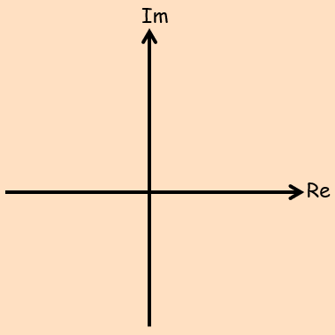
- Show that the three cube roots of 1 can be written as $1+ω+ω^{2}$ where $1+ω+ω^{2}=0$

Summary notes:

- Solve the equation $z^{4}-2\sqrt{3}i=2$
Give your answers in both the modulus-argument and exponential forms.

- Solve the equation:
$$z^{3}+4\sqrt{2}+4i\sqrt{2}=0$$

1G Geometric Problems with Complex Numbers
- Find the 6th roots of the complex number $7+24i$

- Find the 6th roots of unity

Summary notes:

- The coordinate $\left(\sqrt{3},1\right)$ lies at one vertex of an equilateral triangle. The centre of the triangle is at the origin.
Find the coordinates of the other vertices of the triangle
