CP1 Chapter 7

Linear Transformations

Chapter Overview

1. Use matrices to represent linear transformations

2. Use matrices to represent reflections, rotations (about the origin).

3. Invariant Lines and Points

4. Use matrices to represent enlargements.

5. Carry out successive transformations using matrix products.

6. Use inverse matrices to represent reverse transformations.



Linear Transformations

We can use matrices to describe linear transformations. A linear transformation moves all points $(x,y)$ in a plane according to some rule.

Transforming a point $\left(\begin{matrix}x \\ y\end{matrix}\right)$ simply involves multiplying it by some matrix.

From above we can see that multiplying by a matrix $A=\left(\begin{matrix}a & b \\ c & d\end{matrix}\right)$ represents the mapping $T:\left(\begin{matrix}x \\ y\end{matrix}\right)→\left(\begin{matrix}ax+by \\ cx+dy\end{matrix}\right)$.

Example

1. Express the linear transformation $T:\left(\begin{matrix}x \\ y\end{matrix}\right)→\left(\begin{matrix}4x+y \\ x-2y\end{matrix}\right)$ as a matrix.

2. Find matrices to represent these linear transformations.



b)

3. A square has coordinates $\left(1,1\right),\left(3,1\right),(3,3)$ and $(1,3)$. Find the vertices of the image of $S$ under the transformation given by the matrix $M=\left(\begin{matrix}-1 & 2 \\ 2 & 1\end{matrix}\right)$. Sketch $S$ and the image of $S$ on a coordinate grid.

Ex 7a page 129

Determining a matrix for a transformation

Rotations

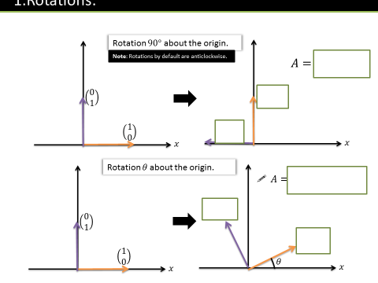

Reflections

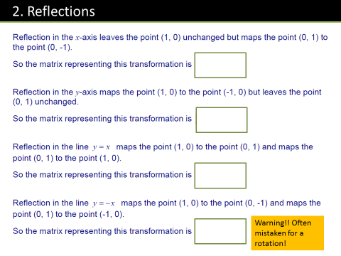

Test Your Understanding

1. Find the matrix representing a reflection in the line .

2. Find the matrix representing a rotation by $270°$.

3.

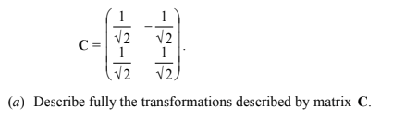

Invariant Lines and Points

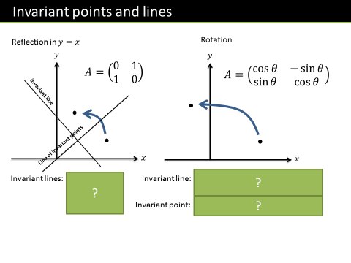

Finding Invariant Points

Finding Invariant Lines

Example

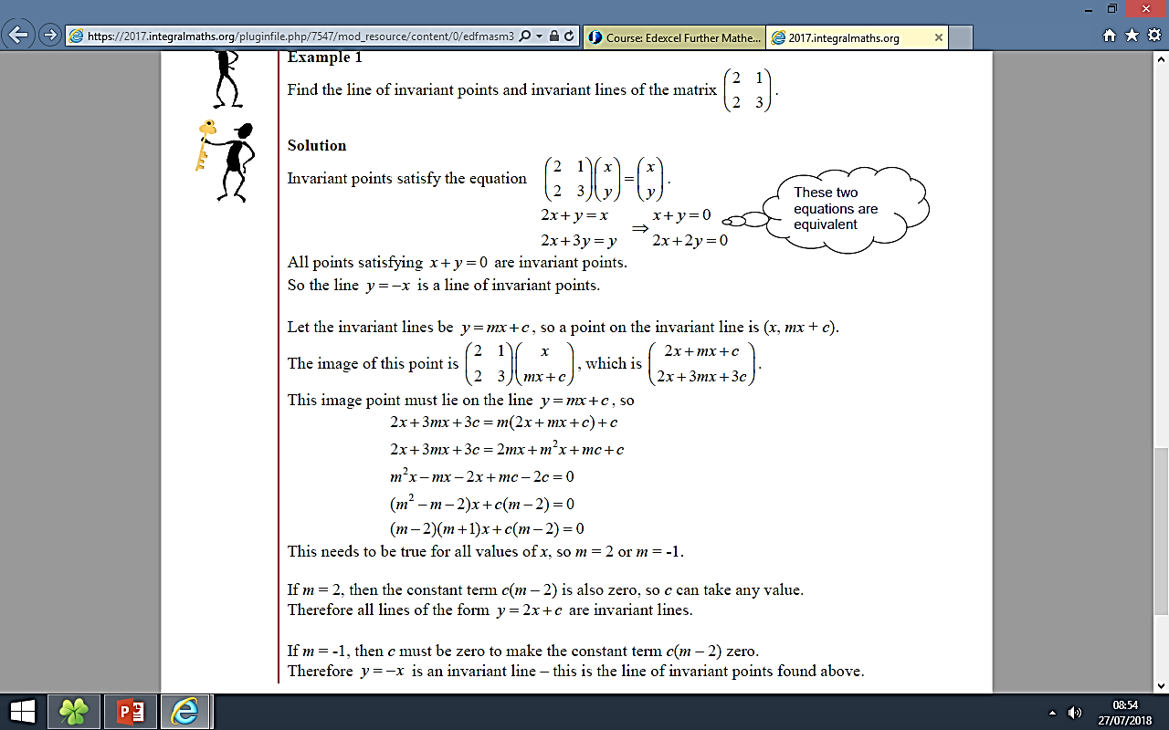

Activity

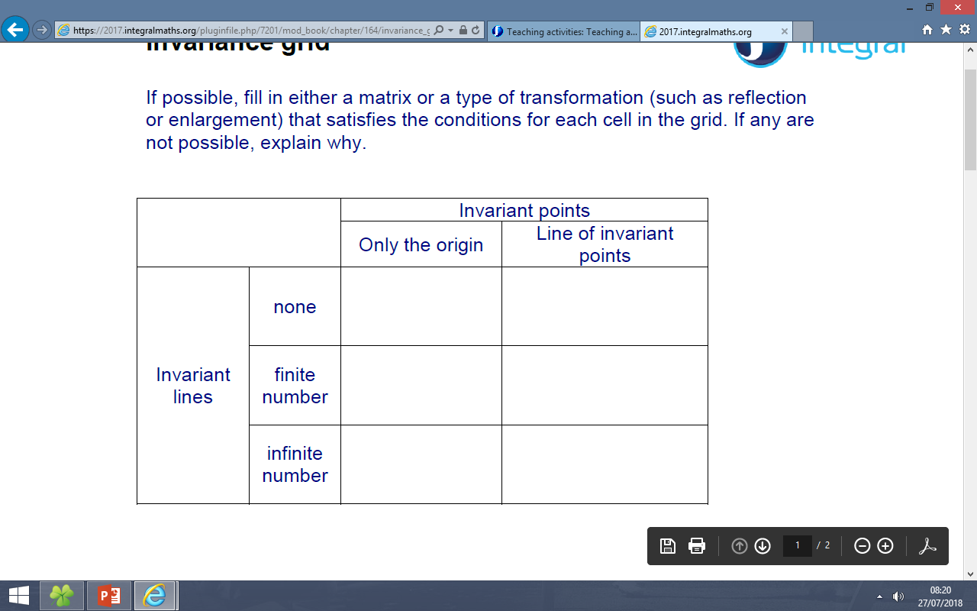

Ex 7b page 134

Enlargements

Enlargements and Invariance

Using the Determinant

Example

$A\left(1,1\right),B\left(1,2\right),C\left(2,2\right)$ are points on a triangle. The transformation with matrix $M=\left(\begin{matrix}4 & 0 \\ 0 & 3\end{matrix}\right)$ is applied to the triangle to produce a new triangle with vertices $A^{'},B'$ and $C'$.

(a) Determine the coordinates of $A^{'}, B^{'},C'$.

(b) What is the area of triangle $ABC$?

(c) What is the area of triangle $A^{'}B^{'}C^{'}$?

(d) Determine $det⁡(M)$. What do you notice?

|  |  |  |
| --- | --- | --- |
| **Area of Object** | **Transformation Matrix** | **Area of Image** |
| $$4$$ | $$\left(\begin{matrix}1 & 2 \\ 3 & 4\end{matrix}\right)$$ |  |
| $$3$$ | $$\left(\begin{matrix}2 & 0 \\ 9 & 4\end{matrix}\right)$$ |  |
| $$9$$ | $$\left(\begin{matrix}5 & 3 \\ -2 & -1\end{matrix}\right)$$ |  |
| $$1$$ | $$\left(\begin{matrix}-5 & 2 \\ -4 & -2\end{matrix}\right)$$ |  |

Test Your Understanding

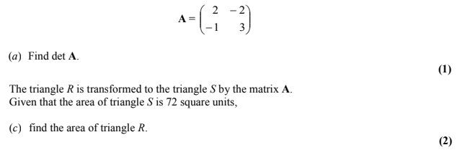

Ex 7c page 138

Combined Transformations

Examples

1. Represent as a single matrix the transformation representing a reflection in the line $y=x$ followed by a stretch on the $x$ axis by a factor of 4.

2. Represent as a single matrix the transformation representing a rotation $90°$ anticlockwise about the point $\left(0,0\right)$ followed by a reflection in the line $y=x$.

Test Your Understanding

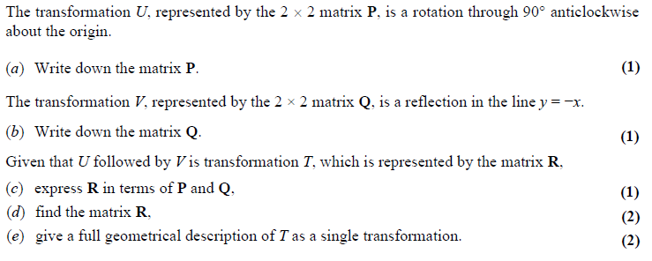

Ex 7D page 141

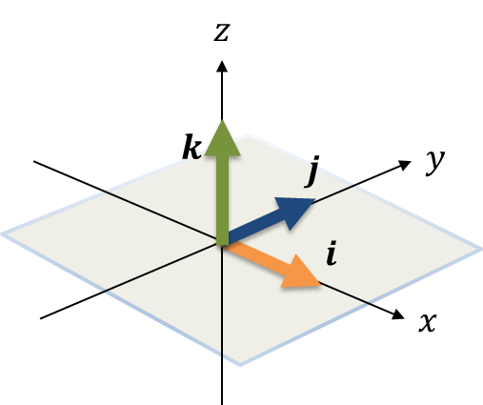Linear Transformations in 3D

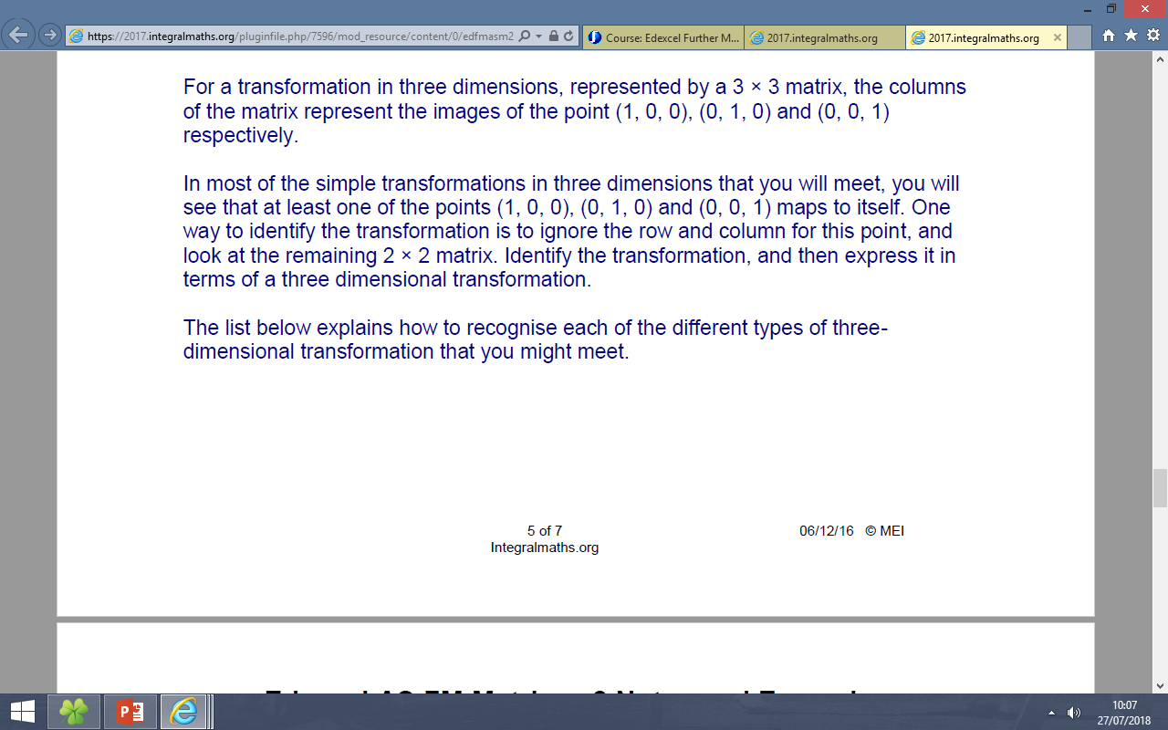

Reflections

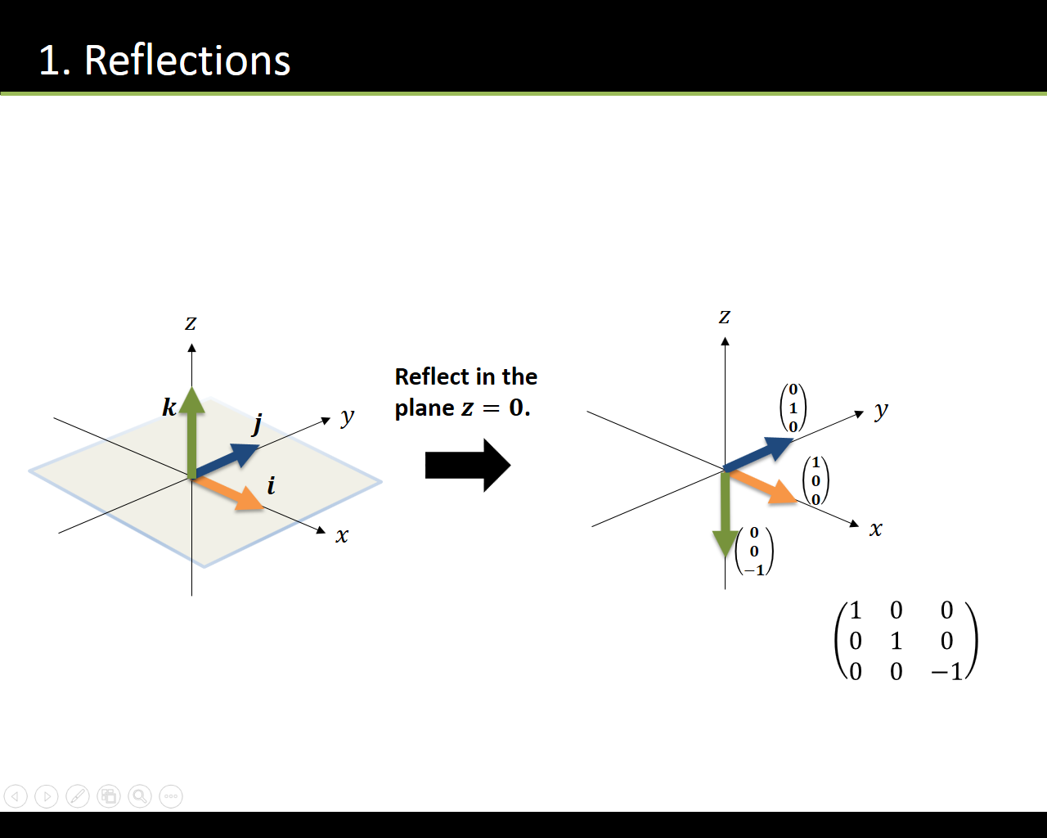

Rotations

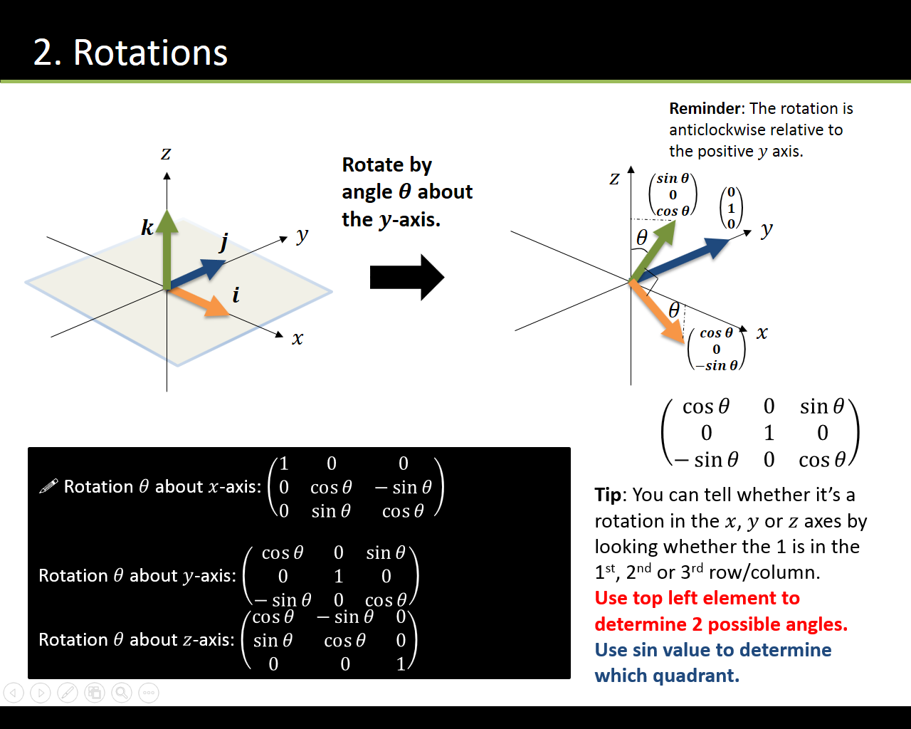

Test Your Understanding

$$M=\left(\begin{matrix}\frac{\sqrt{3}}{2} & 0 & \frac{1}{2} \\ 0 & 1 & 0 \\ -\frac{1}{2} & 0 & \frac{\sqrt{3}}{2}\end{matrix}\right)$$

(a) Describe the transformation represented by $M$.

(b) Find the image of the point with coordinates $\left(-1,-2,1\right)$ under the transformation represented by $M$.

Ex 7E page 146

Inverse Matrices for Inverse Transformations

Example

1. Suppose we want to find the inverse of AB, where A and B are non-singular matrices. This means we need to find a matrix X such that X(AB) = I

2. The triangle $T$ has vertices at $A$, $B$ and $C$. The matrix $M=\left(\begin{matrix}4 & -1 \\ 3 & 1\end{matrix}\right)$ transforms $T$ to the triangle $T'$ with vertices at $A'\left(4,3\right), B'\left(4,10\right)$ and $C'\left(-4,-3\right)$. Determine the coordinates of $A$, $B$ and $C$.

Test Your Understanding

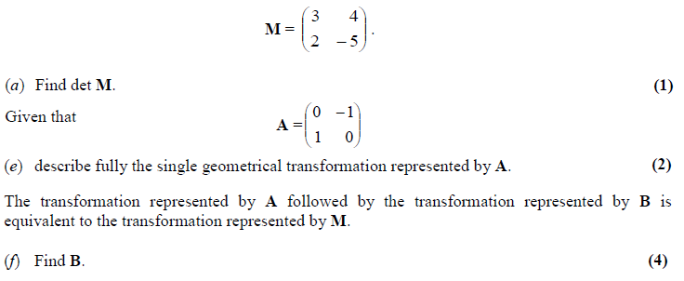

Ex 7F page 148