Inverse Matrices for Inverse Transformations

Example
1. Suppose we want to find the inverse of AB, where A and B are non-singular matrices. This means we need to find a matrix X such that X(AB) = I

2. The triangle $T$ has vertices at $A$, $B$ and $C$. The matrix $M=\left(\begin{matrix}4 & -1 \\ 3 & 1\end{matrix}\right)$ transforms $T$ to the triangle $T'$ with vertices at $A'\left(4,3\right), B'\left(4,10\right)$ and $C'\left(-4,-3\right)$. Determine the coordinates of $A$, $B$ and $C$.

Test Your Understanding

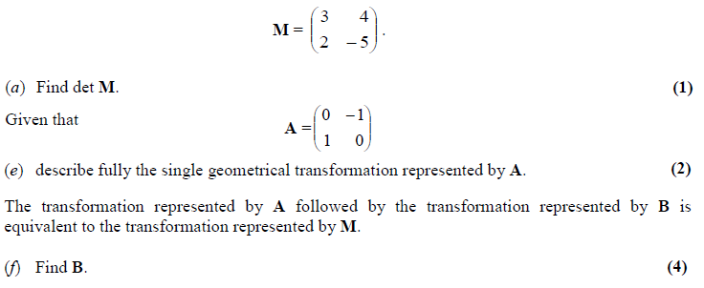

Ex 7F page 148

