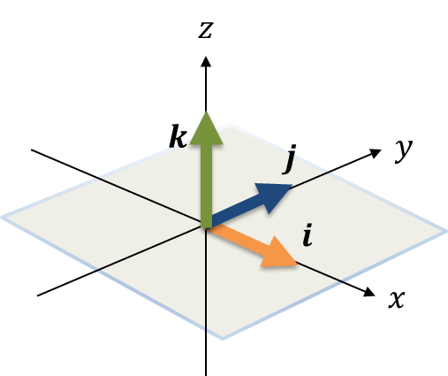
Linear Transformations in 3D

Reflections
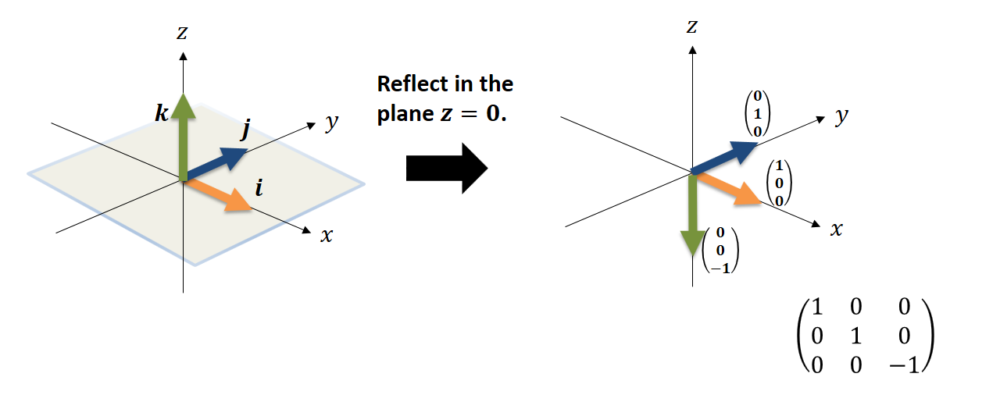

Rotations

Test Your Understanding
$$M=\left(\begin{matrix}\frac{\sqrt{3}}{2} & 0 & \frac{1}{2} \\ 0 & 1 & 0 \\ -\frac{1}{2} & 0 & \frac{\sqrt{3}}{2}\end{matrix}\right)$$
(a) Describe the transformation represented by $M$.
(b) Find the image of the point with coordinates $\left(-1,-2,1\right)$ under the transformation represented by $M$.

Ex 7E page 146

