Combined Transformations

Examples
1. Represent as a single matrix the transformation representing a reflection in the line $y=x$ followed by a stretch on the $x$ axis by a factor of 4.

2. Represent as a single matrix the transformation representing a rotation $90°$ anticlockwise about the point $\left(0,0\right)$ followed by a reflection in the line $y=x$.

Test Your Understanding

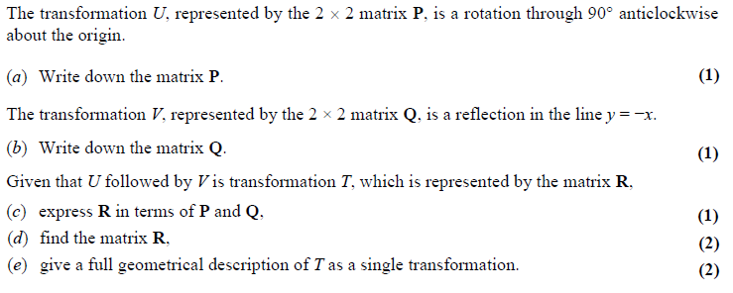

Ex 7D page 141

