7C Enlargements
- The matrix $M=\left[\begin{matrix}3 & 0 \\ 0 & 2\end{matrix}\right]$.
- Find the image $T^{'}$ of the triangle $T$ with vertices (1,1), (1,2) and (2,2) under the transformation represented by $M$.

- Sketch $T$ and $T^{'}$ on the same set of coordinate axes.
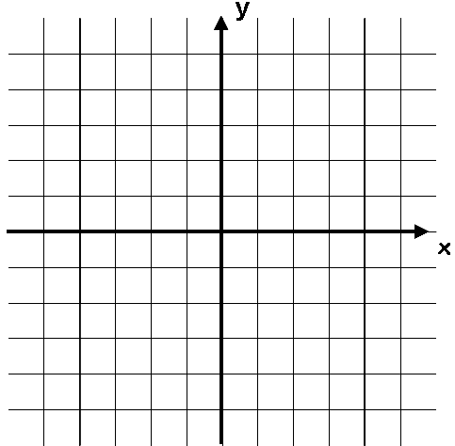
5
-5
5
-5

- Describe geometrically the transformation represented by $M$.

Key note:

The determinant and scale factors:

- The Matrix $M=\left[\begin{matrix}2 & 0 \\ 0 & 4\end{matrix}\right]$.
- Describe fully the transformation represented by matrix $M$

- A triangle $T$ has vertices at (1,0), (4,0) and (4,2). Find the area of the triangle

- Triangle $T$ is transformed by using matrix $M$. Find the area of the image of $T$.

