Enlargements

Enlargements and Invariance

Using the Determinant

Example
$A\left(1,1\right),B\left(1,2\right),C\left(2,2\right)$ are points on a triangle. The transformation with matrix $M=\left(\begin{matrix}4 & 0 \\ 0 & 3\end{matrix}\right)$ is applied to the triangle to produce a new triangle with vertices $A^{'},B'$ and $C'$.
(a) Determine the coordinates of $A^{'}, B^{'},C'$.
(b) What is the area of triangle $ABC$?
(c) What is the area of triangle $A^{'}B^{'}C^{'}$?
(d) Determine $det⁡(M)$. What do you notice?

Area of Object | Transformation Matrix | Area of Image
$$4$$ | $$\left(\begin{matrix}1 & 2 \\ 3 & 4\end{matrix}\right)$$
$$3$$ | $$\left(\begin{matrix}2 & 0 \\ 9 & 4\end{matrix}\right)$$
$$9$$ | $$\left(\begin{matrix}5 & 3 \\ -2 & -1\end{matrix}\right)$$
$$1$$ | $$\left(\begin{matrix}-5 & 2 \\ -4 & -2\end{matrix}\right)$$

Test Your Understanding

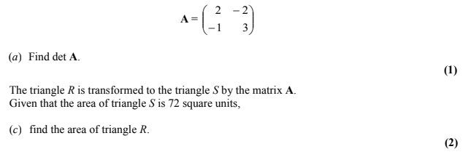

Ex 7c page 138

