Determining a matrix for a transformation

Rotations
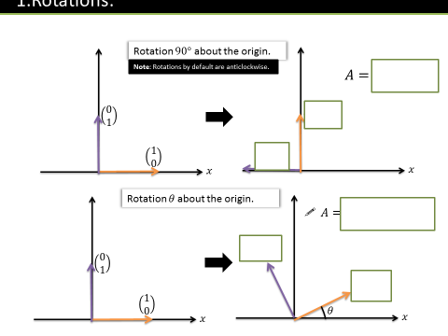

Reflections

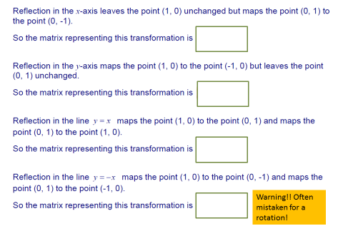

Test Your Understanding
1. Find the matrix representing a reflection in the line $y=x$.

2. Find the matrix representing a rotation by $270°$.

3.
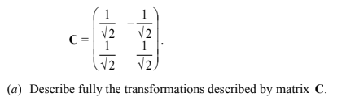

Invariant Lines and Points

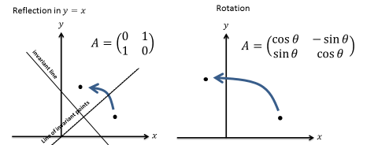

Finding Invariant Points

Finding Invariant Lines

Example

Activity
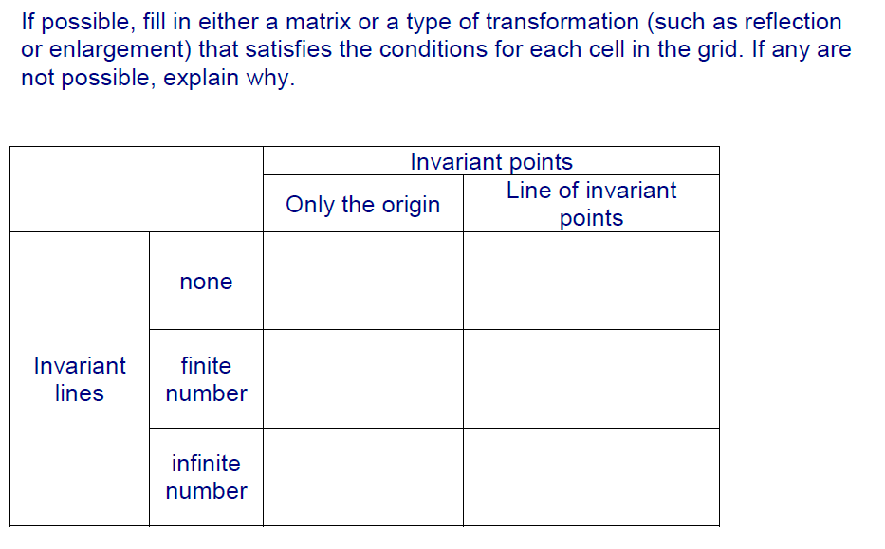

Ex 7b page 134

