7A Introduction to Linear Transformations with Matrices

Linear Transformations

- The three transformations S, T and U are defined below. Find the image of the point (2,3) under each of these transformations. State whether each is a linear transformation.
$$S:\left[\begin{matrix}x \\ y\end{matrix}\right]→\left[\begin{matrix}x+4 \\ y-1\end{matrix}\right]$$

$$T:\left[\begin{matrix}x \\ y\end{matrix}\right]→\left[\begin{matrix}2x-y \\ x+y\end{matrix}\right]$$

$$U:\left[\begin{matrix}x \\ y\end{matrix}\right]→\left[\begin{matrix}2y \\ -x^{2}\end{matrix}\right]$$

Matrices can be used to represent linear transformations:

- Find matrices to represent these linear transformations:
$$T:\left[\begin{matrix}x \\ y\end{matrix}\right]→\left[\begin{matrix}2y+x \\ 3x\end{matrix}\right]$$

$$V:\left[\begin{matrix}x \\ y\end{matrix}\right]→\left[\begin{matrix}-2y \\ 3x+y\end{matrix}\right]$$

- The square S has coordinates (1,1), (3,1), (3,3) and (1,3).
Find the coordinates of the vertices of the image of S after the transformation given by the matrix:
$$M=\left[\begin{matrix}-1 & 2 \\ 2 & 1\end{matrix}\right]$$

7B Reflections & Rotations
(0,1)
(1,0)

- Describe fully the geometrical transformation represented by the matrix:
$$\left[\begin{matrix}3 & 0 \\ 0 & 3\end{matrix}\right]$$

$$\left[\begin{matrix}-1 & 0 \\ 0 & -1\end{matrix}\right]$$

$$\left[\begin{matrix}0 & -1 \\ -1 & 0\end{matrix}\right]$$

- Find a matrix to represent the transformation:
- ‘Reflection in the y-axis’

- ‘Enlargement, centre (0,0), scale factor 2’

- ‘Rotation of 45° anticlockwise about (0,0)’

As a general rule, the matrix representing a rotation of angle $θ$ anticlockwise about the origin is:

Final notes:
Invariant point

Invariant Lines

7E 3D Transformations

$$z$$
$$x$$
$$y$$
$$z$$
$$x$$
$$y$$

$$z$$
$$y$$
$$x$$

- A transformation U, in three dimensions, represents a reflection in the plane $z=0$.
- Write down the $3×3$ matrix that represents this transformation.

- Find the image of the point $\left(-1,2,3\right)$ under this transformation

Reflection in the $yz$ plane ($x=0)$

Reflection in the $xz$ plane ($y=0)$

Reflection in the $xy$ plane ($z=0)$

- A transformation U, in three dimensions, represents a 90˚ anticlockwise rotation around the x-axis
- Write down the $3×3$ matrix that represents this transformation.

- Find the image of the point $\left(-1,2,3\right)$ under this transformation

Rotation anticlockwise $θ$ around the x-axis

Rotation anticlockwise $θ$ around the y-axis

Rotation anticlockwise $θ$ around the z-axis

- The matrix $M=\left[\begin{matrix}\frac{\sqrt{3}}{2} & 0 & \frac{1}{2} \\ 0 & 1 & 0 \\ -\frac{1}{2} & 0 & \frac{\sqrt{3}}{2}\end{matrix}\right]$.
- Describe the transformation represented by $M$.

- Find the image of the point with coordinates $(-1,-2,1)$under the transformation represented by $M$.

7C Enlargements
- The matrix $M=\left[\begin{matrix}3 & 0 \\ 0 & 2\end{matrix}\right]$.
- Find the image $T^{'}$ of the triangle $T$ with vertices (1,1), (1,2) and (2,2) under the transformation represented by $M$.

- Sketch $T$ and $T^{'}$ on the same set of coordinate axes.
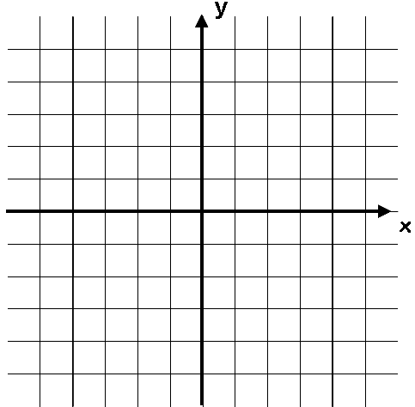
5
-5
5
-5

- Describe geometrically the transformation represented by $M$.

Key note:

The determinant and scale factors:

- The Matrix $M=\left[\begin{matrix}2 & 0 \\ 0 & 4\end{matrix}\right]$.
- Describe fully the transformation represented by matrix $M$

- A triangle $T$ has vertices at (1,0), (4,0) and (4,2). Find the area of the triangle

- Triangle $T$ is transformed by using matrix $M$. Find the area of the image of $T$.

7D Multiple Transformations
- The points A(1,0), B(0,1) and C(2,0) are the vertices of a triangle T. The triangle T is rotated 90° anticlockwise around (0,0) and then the image T’ is reflected in the line y = x to obtain the triangle T’’.
- On separate diagrams, draw T, T’ and T’’

- i) Find the matrix P such that P(T) = T’

ii) Find the matrix Q such that Q(T’) = T’’

- By finding a matrix product, find the single matrix that will perform a 90° anticlockwise rotation followed by a reflection in y = x

- The following matrices represent three different transformations:
$$R=\left[\begin{matrix}3 & 7 \\ -1 & -2\end{matrix}\right]$$
$$Q=\left[\begin{matrix}1 & 2 \\ 0 & 1\end{matrix}\right]$$
$$P=\left[\begin{matrix}1 & 1 \\ 2 & 3\end{matrix}\right]$$

Find the matrix representing the transformation represented by R, followed by Q, followed by P and give a geometrical interpretation of this transformation.

- $M=\left[\begin{matrix}-2\sqrt{2} & -2\sqrt{2} \\ 2\sqrt{2} & -2\sqrt{2}\end{matrix}\right]$
The matrix $M$ represents an enlargement with scale factor $k$ followed by an anticlockwise rotation through angle $θ$ about the origin.
- Find the value of $k$

- Find the value of $θ$

7F Inverse Matrices & Transformations
- The triangle T has vertices at A, B and C. The matrix:
$$M=\left[\begin{matrix}4 & -1 \\ 3 & 1\end{matrix}\right]$$

transforms T to the triangle T’ with vertices at (4,3), (4,10) and (-4,-3).
Find the coordinates of the points A, B and C

- The matrix $A=\left[\begin{matrix}2 & 4 \\ -2 & -5\end{matrix}\right]$ represents a transformation $T$. Given that $T$ maps point $P$ with coordinates (x,y) onto the point $P$’ with coordinates (6,10):
- Find the coordinates of $P$

The matrix $B$ represents a transformation $U$. Given that the transformation $T$ followed by the transformation $U$ is equivalent to a reflection in the line $y=x$:
- Find matrix $B$.

