2G Solving Modulus Equations

- Given the function:
$$t\left(x\right)=3\left|x-1\right|-2, x∈R$$
- Sketch the graph of the function
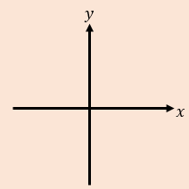
- State the range of the function

- Solve the equation $t\left(x\right)=\frac{1}{2}x+3$

- The function $f$ is defined by:
$$f:x→6-2\left|x+3\right|$$
A sketch of the graph is shown.
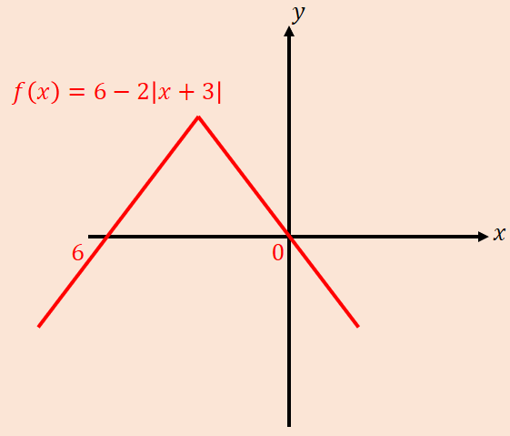
- State the range of $f$

- Explain why $f^{-1}$ does not exist

- Solve the inequality $f\left(x\right)>5$

