2A The |Modulus| Function

- The function f(x) is defined
$$f(x)=\left|2x-3\right|+1$$

find:

- f(5)

- -1)

- a) Sketch the graph of $y=\left|3x-2\right|$
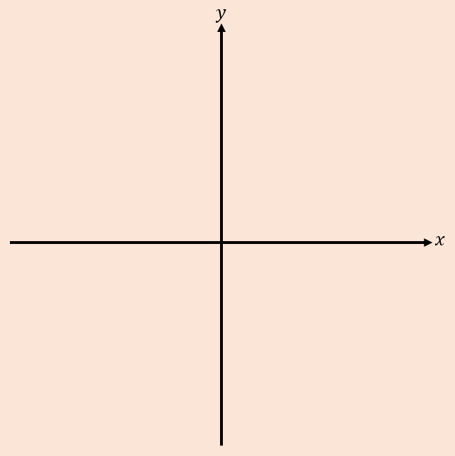

- Solve the equation $\left|2x-1\right|=5$

- Solve the equation $\left|3x-5\right|=2-\frac{1}{2}x$

- Solve the inequality $\left|5x-1\right|>3x$

2B Part 1 Domains & Ranges
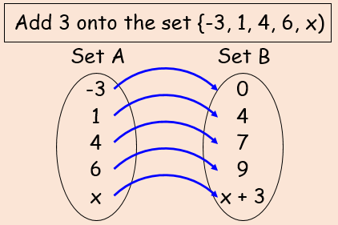

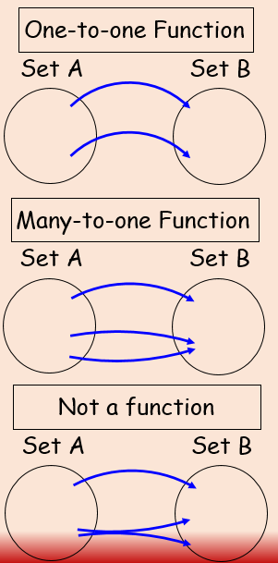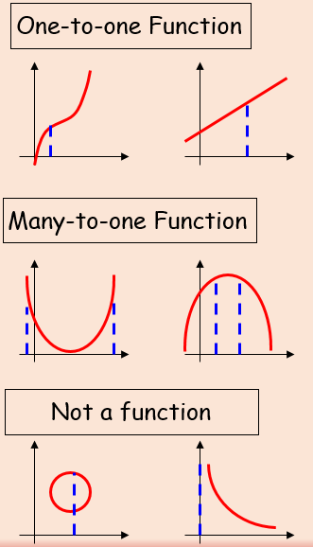

- Find the range of the following function, and state if it is one-to-one or many-to-one.
- f(x) = 3x – 2, domain {x = 1, 2, 3, 4}

- f(x) = 3x – 2, {x = 1, 2, 3, 4}

- g(x) = x², domain {x є R, -5 ≤ x ≤ 5}

- g(x) = x², {-5 ≤ x ≤ 5}

- h(x) = ¹/_{x}, domain {x є R, 0 < x ≤ 3}

- h(x) = ¹/_{x}, {x є R, 0 < x ≤ 3}

2B Part 2 Solving Equations with Functions

- Given that the function g(x) = 2x² + 3, find;
- the value of g(3)

- the value(s) of a such that g(a) = 35

- the range of the function

- The function f(x) is defined by:
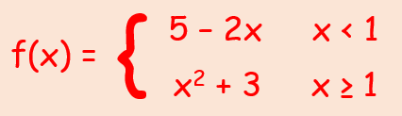
- Sketch f(x) stating its range
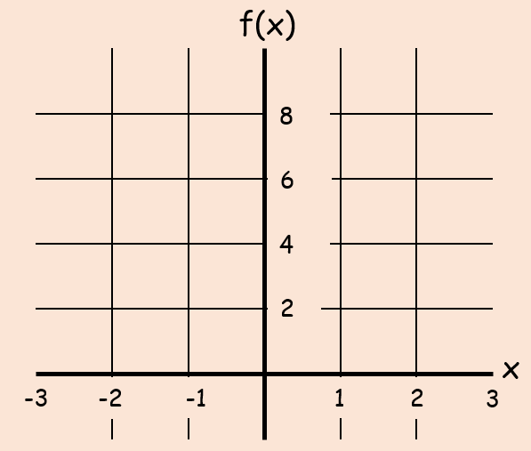

- Find the values of a such that f(a) = 19

2C Composite Functions

- Given:
f(x) = x² g(x) = x + 1
Find:
- fg(x)

- gf(x)

- Given:
f(x) = 3x + 2 g(x) = x² + 4
Find:
- fg(x)

- gf(x)

- f²(x)

- The values of b so that fg(b) = 62

- The functions $f$ and $g$ are defined by:
$$f:x→\left|2x-8\right|$$
$$g:x→\frac{x+1}{2}$$
- Find $fg(3)$

- Solve $fg\left(x\right)=x$

2D Inverse Functions

- Find the inverse of the function:
$$f\left(x\right)=\frac{3}{x-1}, \left\{x∈R, x≠1\right\}$$

- The function:
$f\left(x\right)=\sqrt{x-2}, x∈R, x≥2$
- State the range of $f(x)$

- Find the function $f^{-1}(x)$ and state its domain and range

- Sketch $y=f(x)$ and $y=f^{-1}(x)$ and the line $y=x$

- The function $f(x)$ is defined by:
$$f\left(x\right)=x^{2}-3, x∈R, x≥0.$$
- Find $f^{-1}(x)$

- Sketch $y=f^{-1}(x)$ and state its domain

- Solve the equation $f\left(x\right)=f^{-1}(x)$

2E Modulus Graphs

- Given that:
$$g\left(x\right)=sinx, -360≤x≤360$$
- Sketch $y=g(x)$
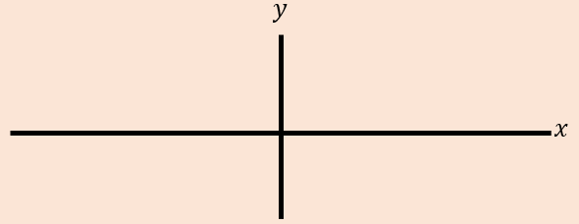
- Sketch $y=\left|g(x)\right|$
- Sketch $y=g\left(\left|x\right|\right)$
- The diagram shows the graph of $y=h(x)$, with five points labelled.
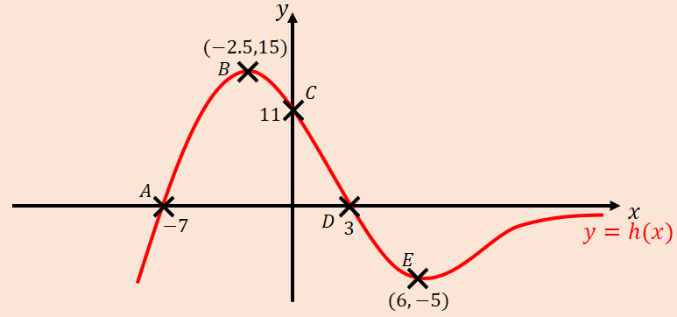
Sketch each of the following graphs, labelling points corresponding to $A$, $B$, $C$, $D$ and $E$, as well as any intersections with the axes.
- $y=\left|h(x)\right|$
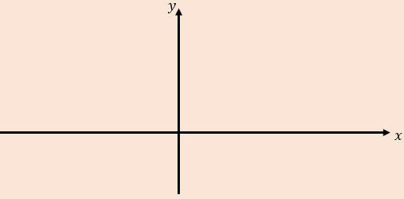

- $y=h\left(\left|x\right|\right)$

2F Multiple Graphical Transformations

- The diagram shows the sketch of $y=f(x)$.
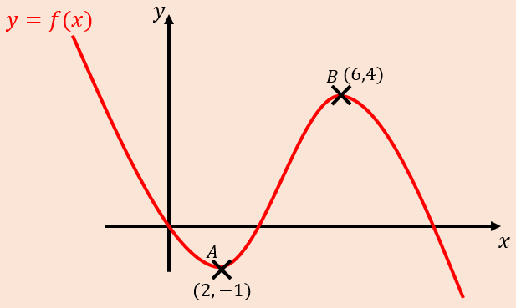
- Sketch the graph of $y=2f\left(x\right)-1$
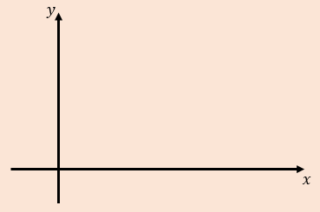
- Sketch the graph of $y=f\left(x+2\right)+2$
- Sketch the graph of $y=\frac{1}{4}f\left(2x\right)$
- Sketch the graph of $y=-f\left(x-1\right)$
- Given that:
$$f\left(x\right)=lnx, x>0$$
Sketch the graphs of:
- $y=2f\left(x\right)-3$
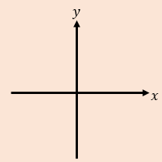
- $y=\left|f(-x)\right|$
2G Solving Modulus Equations

- Given the function:
$$t\left(x\right)=3\left|x-1\right|-2, x∈R$$
- Sketch the graph of the function
- State the range of the function

- Solve the equation $t\left(x\right)=\frac{1}{2}x+3$

- The function $f$ is defined by:
$$f:x→6-2\left|x+3\right|$$
A sketch of the graph is shown.
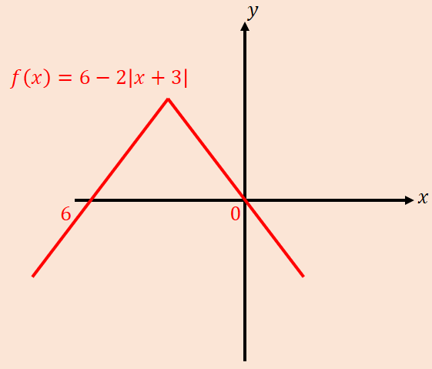
- State the range of $f$

- Explain why $f^{-1}$ does not exist

- Solve the inequality $f\left(x\right)>5$

