**QQQ - PureYr1 - Chapter 9 –   
Trigonometric Ratios (v4)**

**Total Marks: 17**(17 = Platinum, 15 = Gold, 13 = Silver, 11 = Bronze)

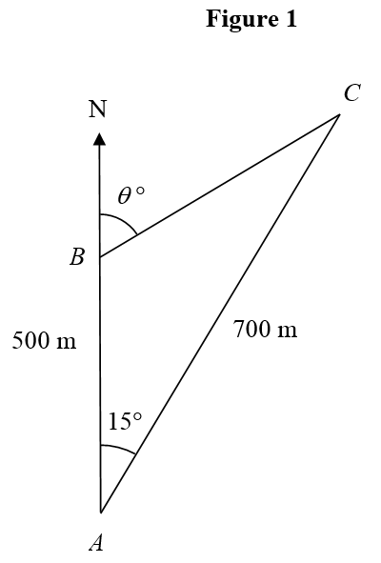**1.**

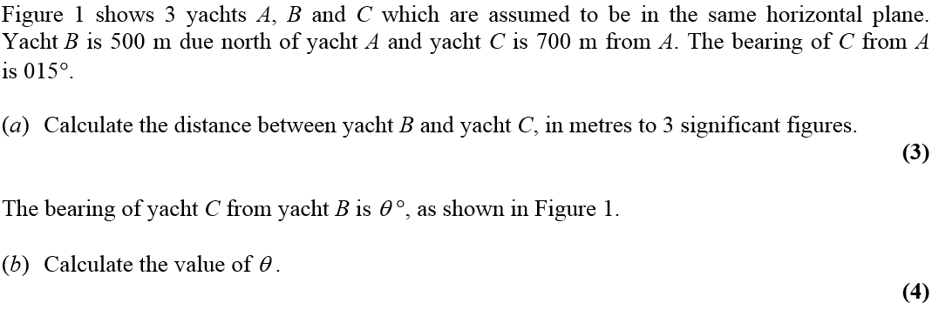

**2.**

