QQQ - PureYr1 - Chapter 9 –
Trigonometric Ratios (v3)
Total Marks: 16
(16 = Platinum, 14 = Gold, 12 = Silver, 10 = Bronze)

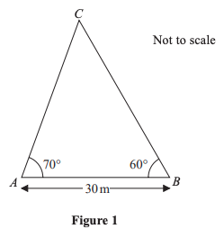
1. A triangular lawn is modelled by the triangle $ABC$ , shown in Figure 1. The length $AB$ is to be 30 m long. Given that angle $BAC={70}^{°}$ and angle $ABC={60}^{°}$ , calculate the area of the lawn to 3 significant figures. (4)
2.
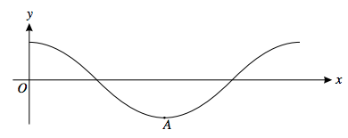
The diagram shows part of the curve $y= cos 2x$ , where $x$ is in degrees. The point A is the minimum point of this part of the curve.
State the coordinates of A. (2)

3. In the triangle 𝐴𝐵𝐶 , 𝐴𝐵 = 11 cm, 𝐵𝐶 = 7 cm and 𝐶𝐴 = 8 cm. Find the area of triangle 𝐴𝐵𝐶 , giving your answer in cm2 to 3 significant figures. (3)

4. In the triangle 𝐴𝐵𝐶 , 𝐴𝐵 = 16 cm, 𝐴𝐶 = 13 cm, angle 𝐴𝐵𝐶 = 50° and angle 𝐵𝐶𝐴 = 𝑥 °
(a) Find the size of angle 𝐶 , giving your answer in degrees to 3 significant figures. (3)
(b) Find the two possible values for 𝑥 , giving your answers to one decimal place. (4)

Solutions (all questions © Edexcel)
1.
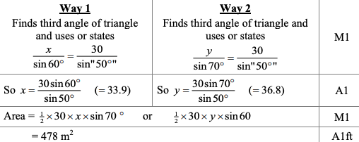

2.
$(90, -1)$ B1 B1

