9G Graphical Transformations of Trigonometric Graphs

- The graph shows the Function:
f(x) = Sinθ + k
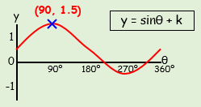
- Write down the value of k

- What is the smallest positive value of θ that gives a minimum point?

- What is the value of Sinθ at this point?

- The graph shows the Function:
f(x) = Cos(θ + k)
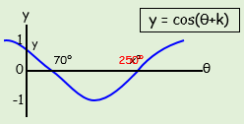
- Write down the value of k

- What is the value of θ at x?

- What are the coordinates of the minimum?

- What is the value of Cosθ at y?

