9D Trigonometric Area Formula

- Calculate the area of the triangle shown below
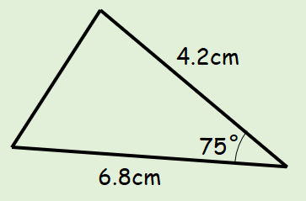

- The area of the triangle to the right is 60cm².
Show that x² – 3x - 240 = 0
