9B The Sine Rule

- Calculate the labelled side in the triangle below:
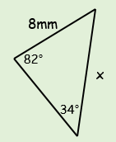

- Calculate the labelled angle in the triangle to the right:
