9A The Cosine Rule

- A triangle has sides of 4cm, 5cm and 6cm respectively. Find the size of the smallest angle

- Coastguard station B is 8km on a bearing of 060˚ from coastguard station A. A ship C is 4.8km, on a bearing of 018˚, away from A.

- In the triangle below, PQ = xcm, QR = (x + 2)cm, RP = 5cm and angle PQR = 60˚. Find the value of x.
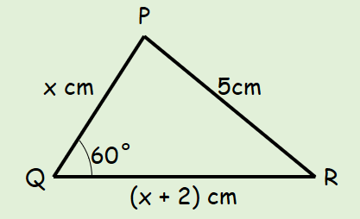

9B The Sine Rule

- Calculate the labelled side in the triangle below:
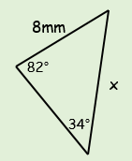

- Calculate the labelled angle in the triangle to the right:
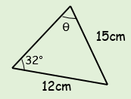

9C The Sine Rule (Ambiguous Case)

- In triangle ABC, AB = 4cm, BC = 3cm and angle BAC = 44°. Work out the possible values of ACB.

9D Trigonometric Area Formula

- Calculate the area of the triangle shown below
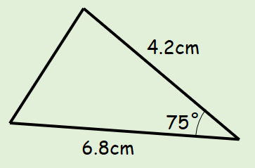

- The area of the triangle to the right is 60cm².
Show that x² – 3x - 240 = 0
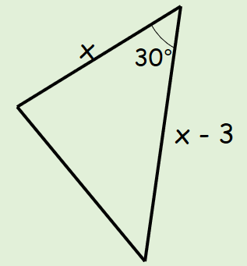

9E Problem Solving
- The diagram shows the locations of four mobile phone masts in a field. $BC=75m$, $CD=80m$, angle $BCD=55^{°}$ and angle $ADC={140}^{°}$
The masts must be at least 70m apart so that they do not interfere with each other. Given that A is the minimum distance from D, find the distance AB.
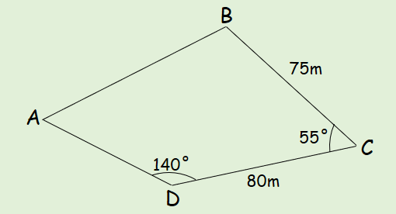

9F Trigonometric Graphs

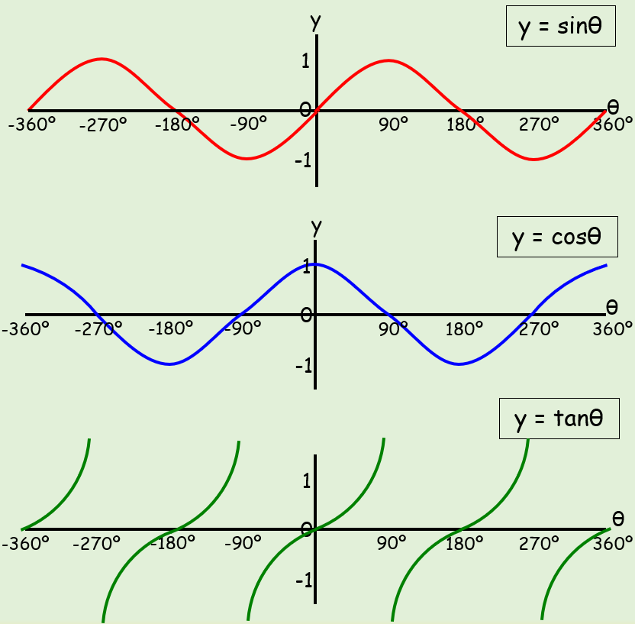

9G Graphical Transformations of Trigonometric Graphs

- The graph shows the Function:
f(x) = Sinθ + k
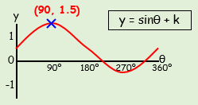
- Write down the value of k

- What is the smallest positive value of θ that gives a minimum point?

- What is the value of Sinθ at this point?

- The graph shows the Function:
f(x) = Cos(θ + k)
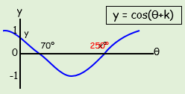
- Write down the value of k

- What is the value of θ at x?

- What are the coordinates of the minimum?

- What is the value of Cosθ at y?

