8C ^{n}C_{r} with Binomials
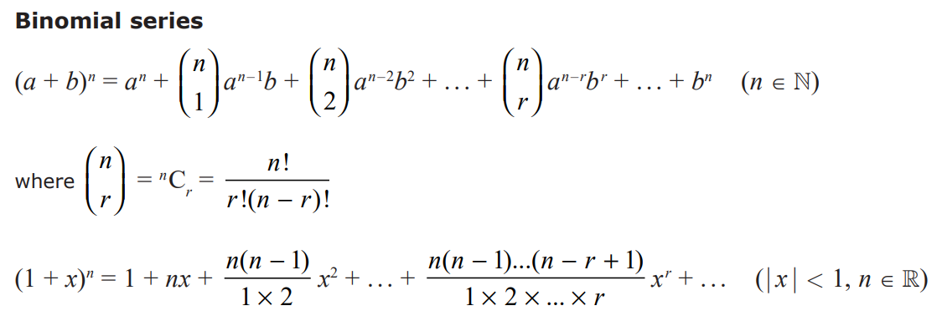

- Use the binomial theorem to find the expansion of ${\left(3-2x\right)}^{5}$

- Find the first 4 terms in the expansion of ${\left(1+2x\right)}^{10}$

- Find the first 4 terms in the expansion of ${\left(10-\frac{1}{2}x\right)}^{6}$

