8A Introduction & Pascal’s Triangle

- Find the expansion of (x + 2y)³

- Find the expansion of (2x - 5)⁴

- The coefficient of x² in the expansion of (2 - cx)³ is 294. Find the value of c.

8B ^{n}C_{r}

- Calculate $6!$

- Calculate ${}_{}^{8}{C_{3}}$

- Calculate ${}_{}^{9}{C_{3}}$ and ${}_{}^{9}{C_{6}}$, and comment on your answers

8C ^{n}C_{r} with Binomials
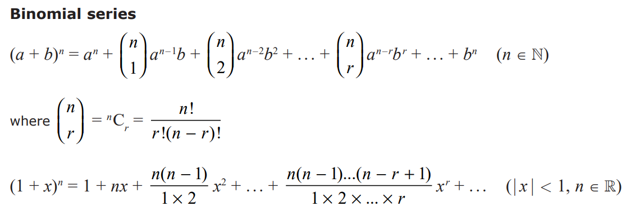

- Use the binomial theorem to find the expansion of ${\left(3-2x\right)}^{5}$

- Find the first 4 terms in the expansion of ${\left(1+2x\right)}^{10}$

- Find the first 4 terms in the expansion of ${\left(10-\frac{1}{2}x\right)}^{6}$

8D Finding Coefficients in Expressions

- Find the coefficient of $x^{4}$ in ${\left(2+3x\right)}^{10}$

- Find the coefficient of $x^{3}$ in ${\left(2+x\right)\left(3-2x\right)}^{7}$

- If $g\left(x\right)={(1+kx)}^{10}$, where $k$ is a constant, and the coefficient of $x^{3}$ is 15, find the value of $k$.

- Write down the first three terms, in ascending powers of $x$, of the binomial expansion of ${(1+qx)}^{8}$, where $q$ is a non-zero constant.

- Given that, in the expansion of ${(1+qx)}^{8}$, the coefficient of $x$ is $–r$and the coefficient of $x^{2}$ is $7r$, find the values of $q$ and $r$

8E Using the Binomial Expansion for Approximations
…

- Find the first four terms of the binomial expansion of ${\left(1-\frac{x}{4}\right)}^{10}$, in ascending powers of $x$

- Use your expansion to estimate the value of 0.975¹⁰, giving your answer to 4 decimal places

