6C Equations of Circles
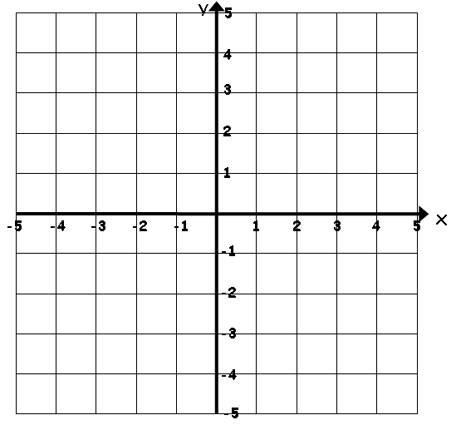

- Write down the equation of the circle with centre (5,7) and radius 4

- Find the coordinates of the centre, and the radius of, the circle with the following equation:
$${\left(x+3\right)}^{2}+{\left(y-1\right)}^{2}=4^{2}$$

- Find the coordinates of the centre, and the radius of, the circle with the following equation:
$${\left(x-\frac{5}{2}\right)}^{2}+{\left(y+4\right)}^{2}=32$$

- Show that the circle:
$${\left(x-3\right)}^{2}+{\left(y+4\right)}^{2}=20$$
Passes through (5,-8)

- The line AB is the diameter of a circle, where A and B are (4,7) and (-8,3) respectively. Find the equation of the circle.

- Find the centre and radius of the circle with equation:
$$x^{2}+y^{2}-14x+16y-12=0$$

